**READ OPERATIONS IN CASSANDRA**

In Cassandra read operation performs through different stages to find the data starting from MEMTABLE (RAM) to the end of the data present in SS TABLES(DISK)

**COMPONENTS USED TO PASS THE READ QUERY** :

* Memtable
* Row cache
* Key cache
* Bloom filters
* Partition summary
* Partition index
* SS Tables

**STEPS TO BE FOLLOWED TO READ THE DATA FROM CASSANDRA :**

* The read request is made from the client
* The data which is requested will be made first checked in MEMTABLE
* If the requested data is found in the MEMTABLE ,then it will be read from MEMTABLE and merged with SSTABLE , then it will be sent to the client

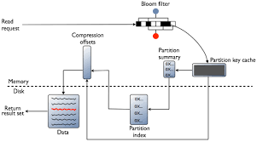

**EXECUTION OF READ PATH IN CASSANDRA :**

* Any server can be queried , which acts as coordinator node in cassandra
* If we want to access the read data , then we need contact nodes and requested key
* On each node, in data center , the data is pulled from either memtable or sstable and merged
* We can check consistency , while reading the data from Cassandra

