**Configure Agent(linux-slave)machine with Jenkins Master using SSH key file connection - as Oracle OS user**

* The Linux (slave) agent machine to be configured using SSH key file as Oracle OS user.
* We have earlier successfully configured Agent using SSH key file as Jenkins user under /home/jenkins/jenkins-agent.
* The same process is followed for Oracle user as well, but the JDK files have to be copied to /home/oracle/Jenkins-agent.
* The purpose of Agent connection as Oracle user, in our case is to perform Oracle database activities in Database server through Jenkins jobs.

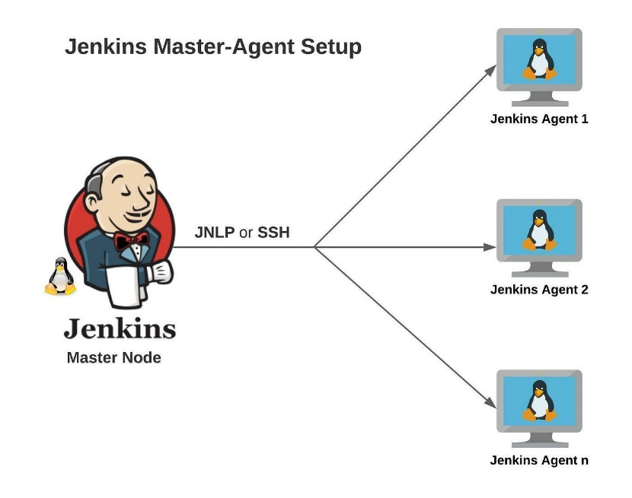

**What is SSH key based connection?**

* SSH key pairs are two cryptographically secure keys that is used to authenticate client machine to Server.
* SSH keys provide an extremely secure way of logging into your server
* The password based SSH connection should be avoided to authenticate as it is not secure to do so.
* The SSH key based connection is safe and secure to connect between the client and the server.
* Each key pair consists of a public key and a private key.
* The private key is retained by the slave machine and should be kept absolutely secret.
* The associated public key can be shared freely without any negative consequences.
* The public key is uploaded to a Server that you want to be able to log into with SSH.
* The public key is added to a special file within the user account you will be logging into called ~/.ssh/authorized_keys.

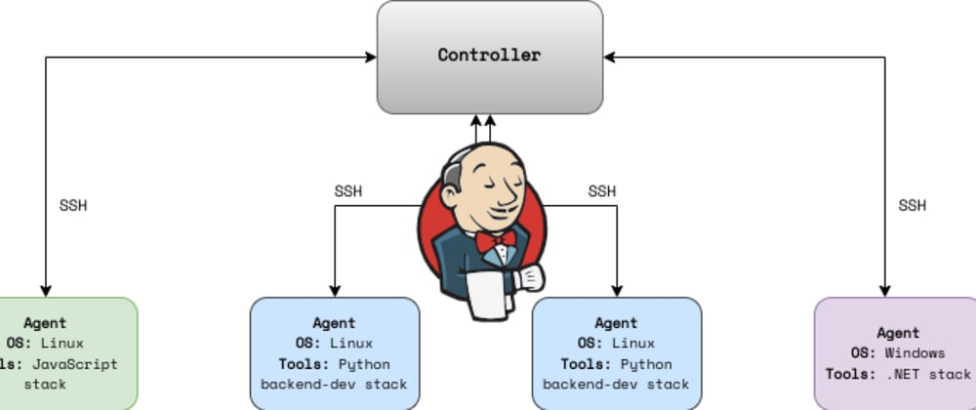

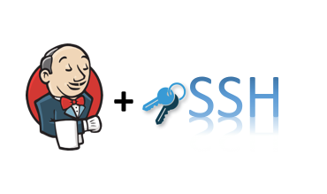

**Step 1: Create user oracle in /home directory of slave machine and create password as well.**

* Create oracle OS account/user in slave machine.
* Create new password as well for the oracle account.

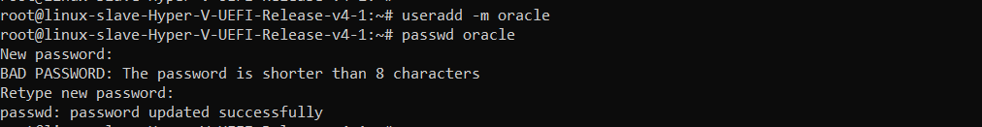

**Ste 2: Test the SSH password authentication using oracle user**

* Test SSH connection using oracle user/password to slave machine from the master node .
* If the SSH connection is successful by username/password authentication, we are good to create SSH key for the oracle account in Slave machine.

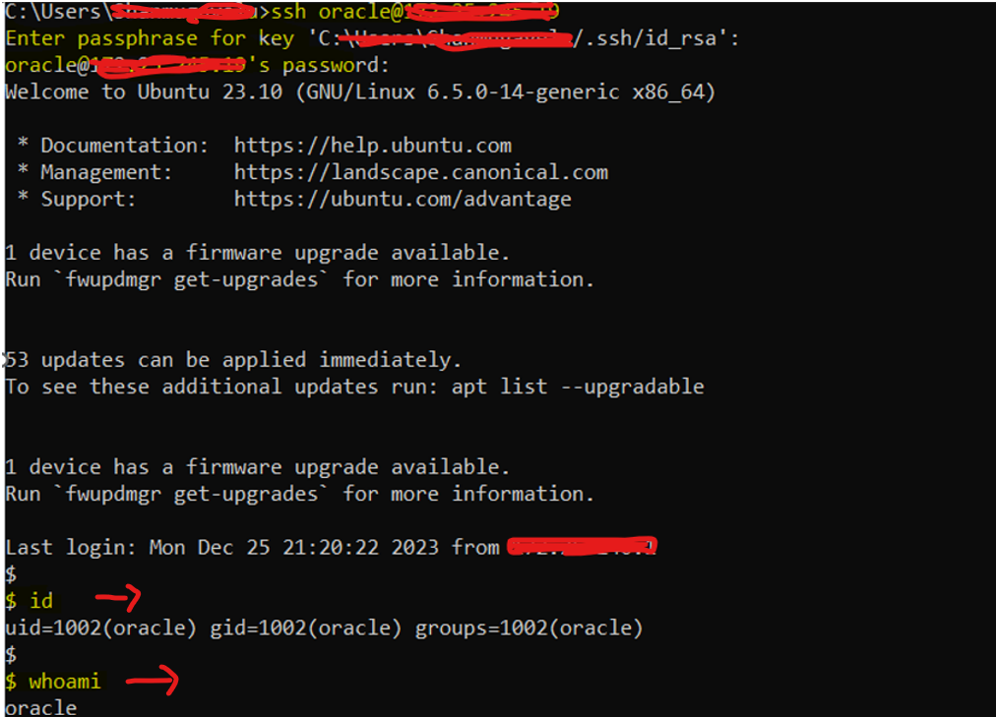

**Step 3: Make directory .ssh under /home/oracle**

* Make the .ssh directory under oracle home ( /home/oracle).

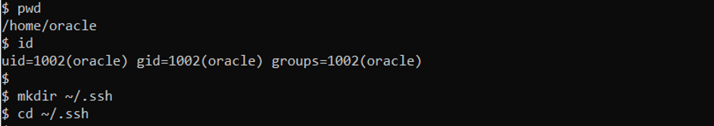

**Step 4: create an SSH key for Oracle user in /home/oracle/.ssh**

* Create the SSH key pair (private and public key ) as in below screenshot under the directory /home/oracle/.ssh as oracle user.

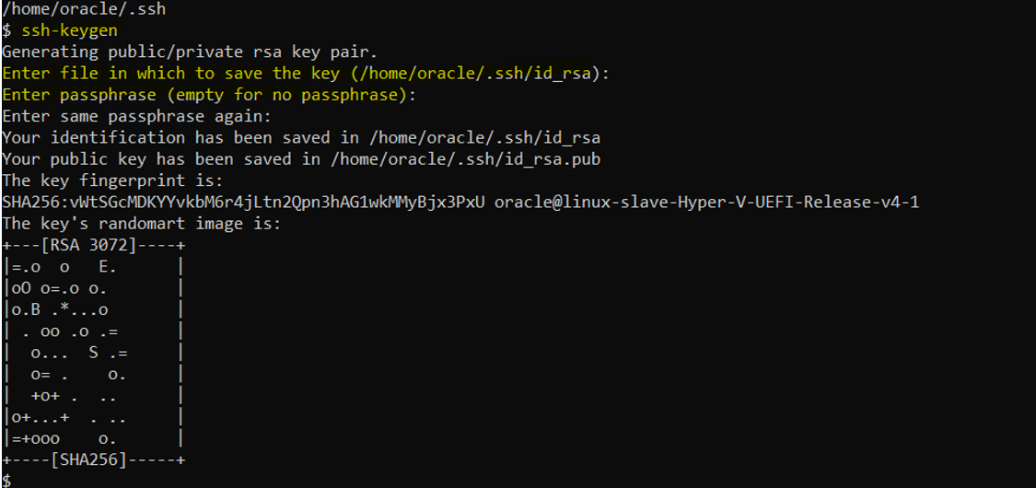

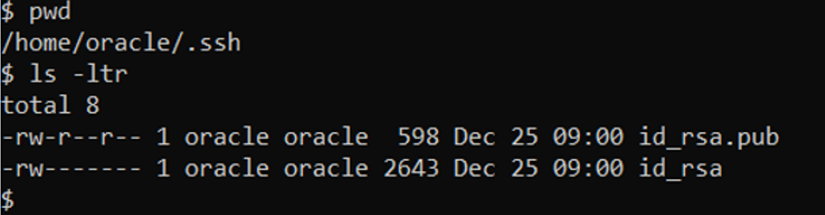

**Step 5: Create authorized_keys file and copy the entry from public key file**

* Create authorized_keys file and add entries from public key file
* Provide 400 permission to authorized_keys file. 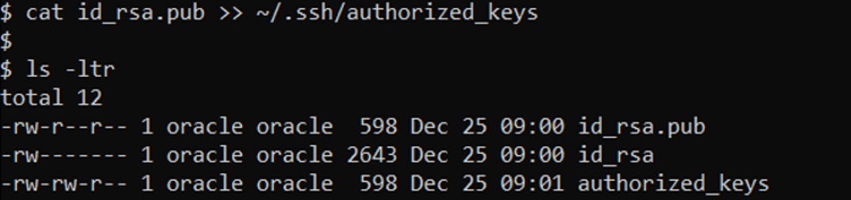

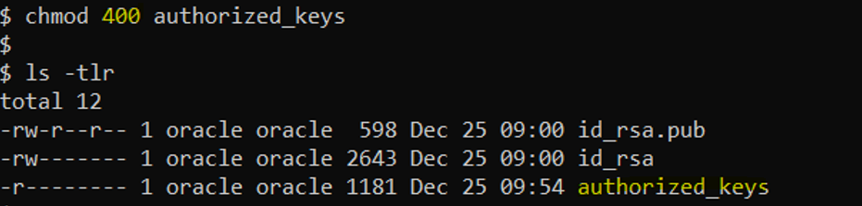

**STEP 6: Copy the java(JDK) files from /home/jenkins/jenkins-agent to the oracle directory /home/oracle/jenkins-agent**

* JDK (java) has to be installed in order to configure the Agent (slave) in jenkins.
* Java has been installed already and the required files exist for agent registration as jenkins user under directory /home/jenkins/jenkins-agent .
* We will make use of the same files by copying to /home/oracle/jenkins-agent.
* We will change the ownership of the files/directories to Oracle owner.

— owner and group 🡪 oracle: oracle

—copying the files from /tmp will directly convert the ownership to oracle .

* **Note: Copy all the files and directories using -R option ( recursive)**

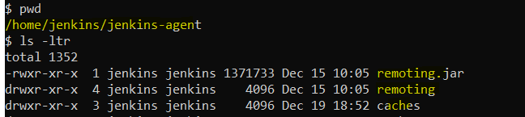

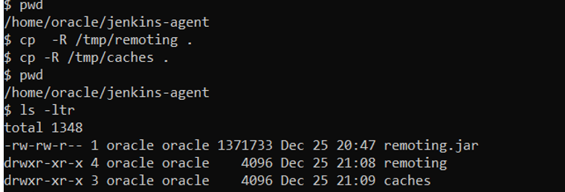

**STEP 7: Add the environment variables JAVA_HOME and PATH variable at the end of .profile file of oracle user .**

* Add the environment variable for JAVA_HOME and PATH at the end of **.profile** file (as Oracle user).
* Check the environment variable with fresh login to oracle (commands: echo $JAVA_HOME and echo $PATH).

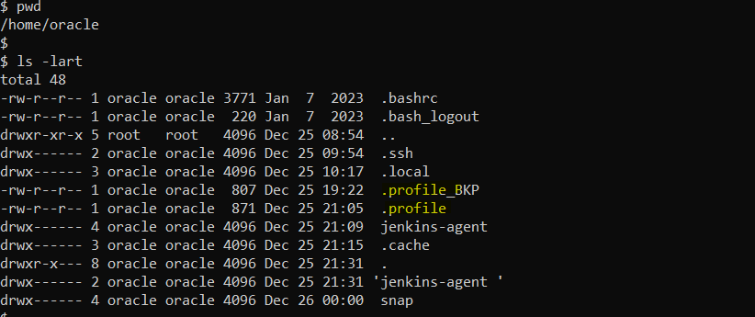

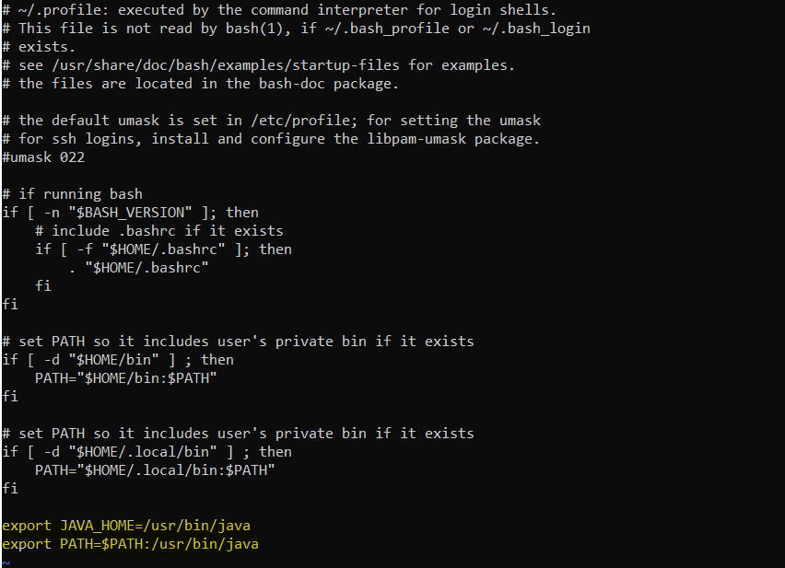

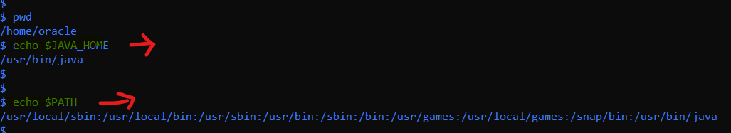

**STEP 8 : 🡪Check the Pre-requisites are met before configuring Agent**

* Jenkins Server (Master node) installed and up and Ready
* Another server for configuring slave (In this article, we are taking Linux with 2GB memory)
* Both the Jenkins server and slave server are in the same network.

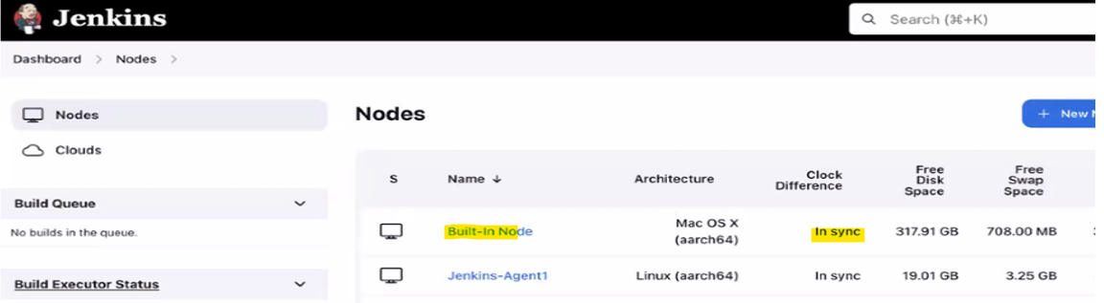

**STEP 9: Configure the Master node in Jenkins console**

* Go to **Manage Jenkins** -> **Manage Nodes** -> **New Node**
* Enter the **Node Name** (slave name as **oracleSSHKey** ) and select **Permanent Agent**then click **OK**
* Then a new form will open and enter the details one by one as follows.
  1. Edit the Description (Optional).
  2. Enter the # of Executor (2 **Executors**).
  3. Then enter the Remote FS Root which is going to be the root directory of the Jenkins slave from the master. **(/home/oracle/jenkins-slav**e ).
  4. Select the launch, Method. (**Launch Agent via SSH**).
  5. Enter the Host **IP address**.
  6. Add credential – by clicking the +**Add** button .
  7. Select the Credentials Kind as – SSH username with private key.
  8. Enter the ID and description
  9. Paste the Private key copying from server – click the **Private key- Enter directly** option (text box) and save.
  10. Select the credentials saved in previous step which we created **“oracle(oraclesshkey) ”** credential.
  11. Select “**Non verifying Verification Strategy**” for Host key Verification Strategy.
  12. Others keep default values.
  13. Click Save.

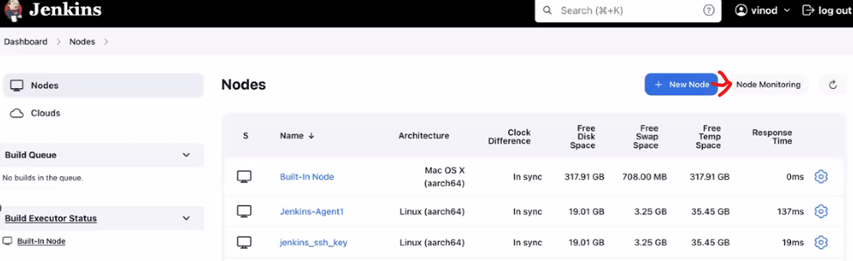

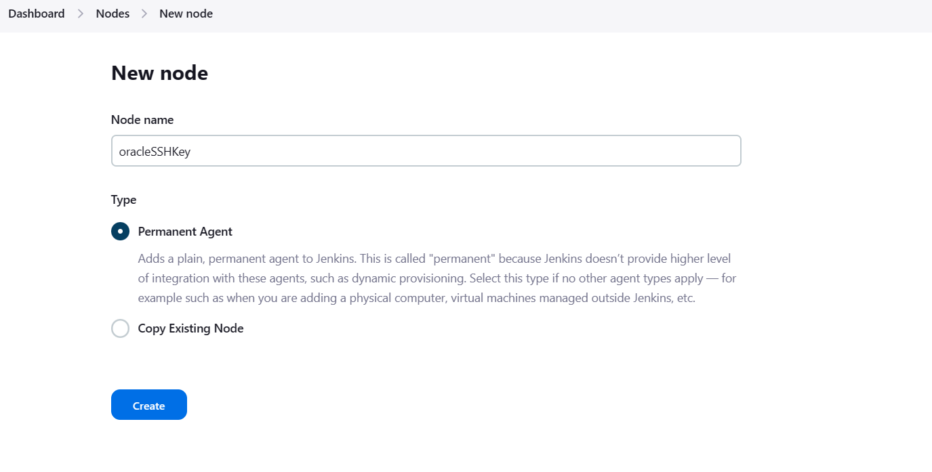

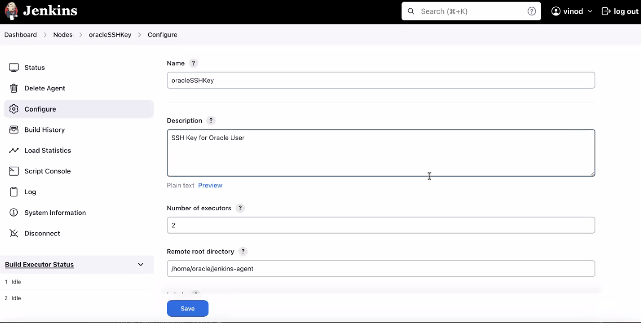

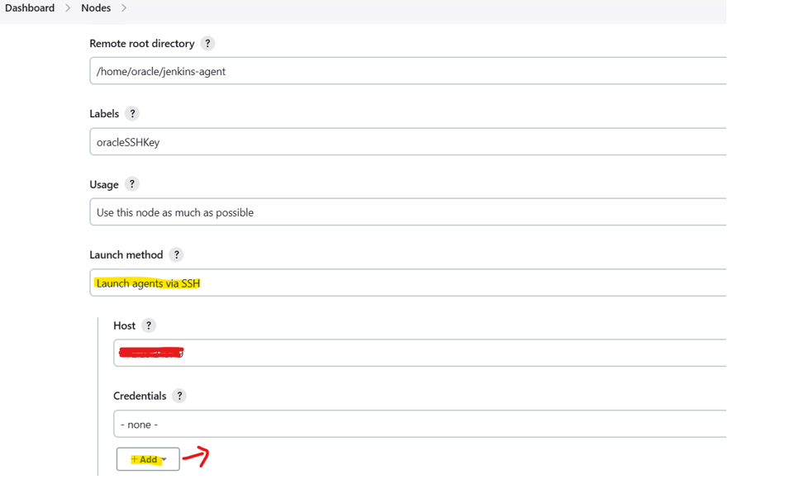

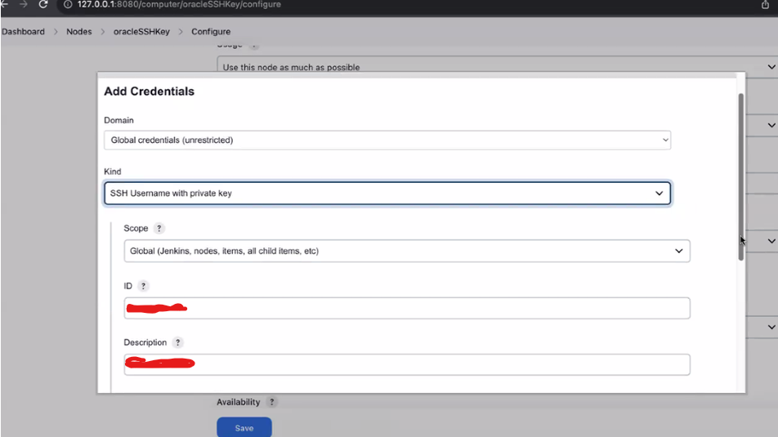

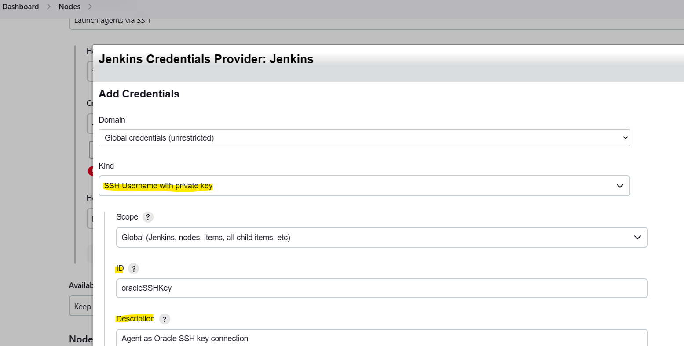

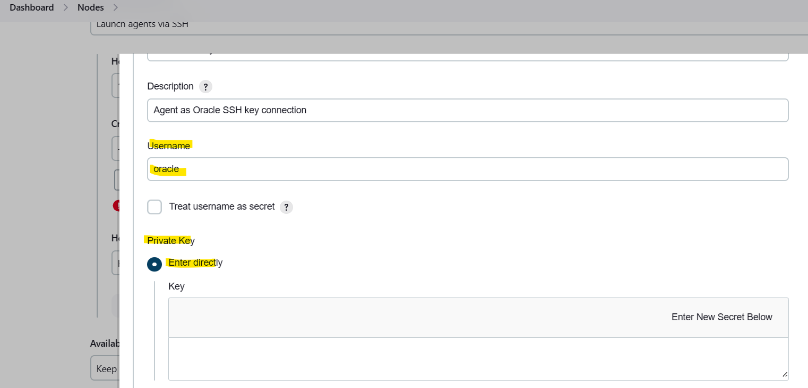

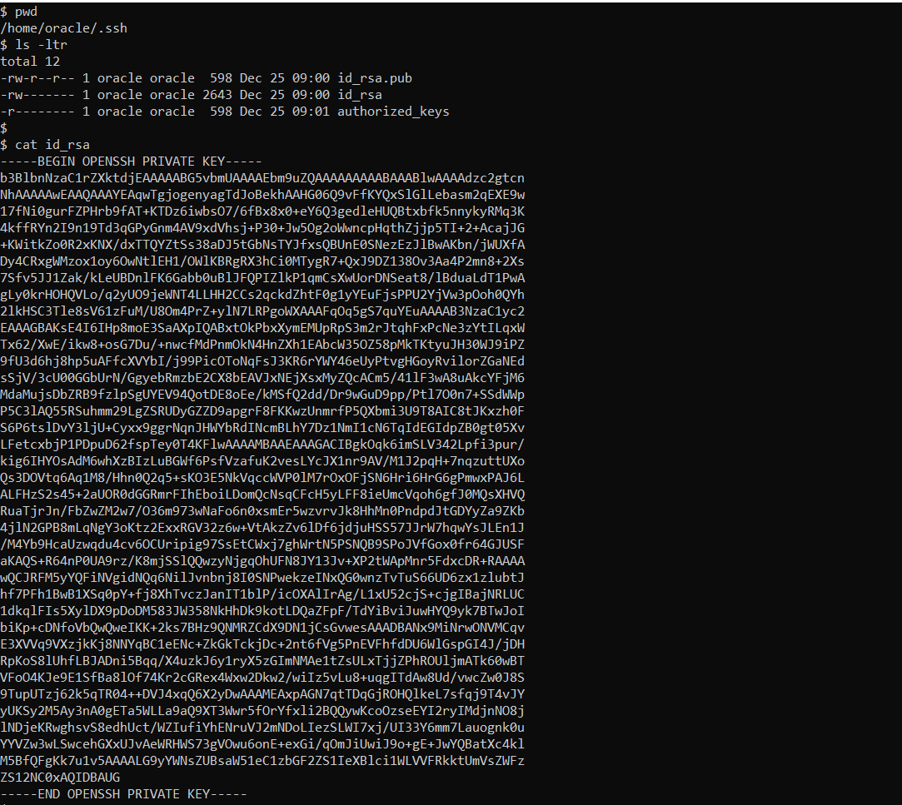

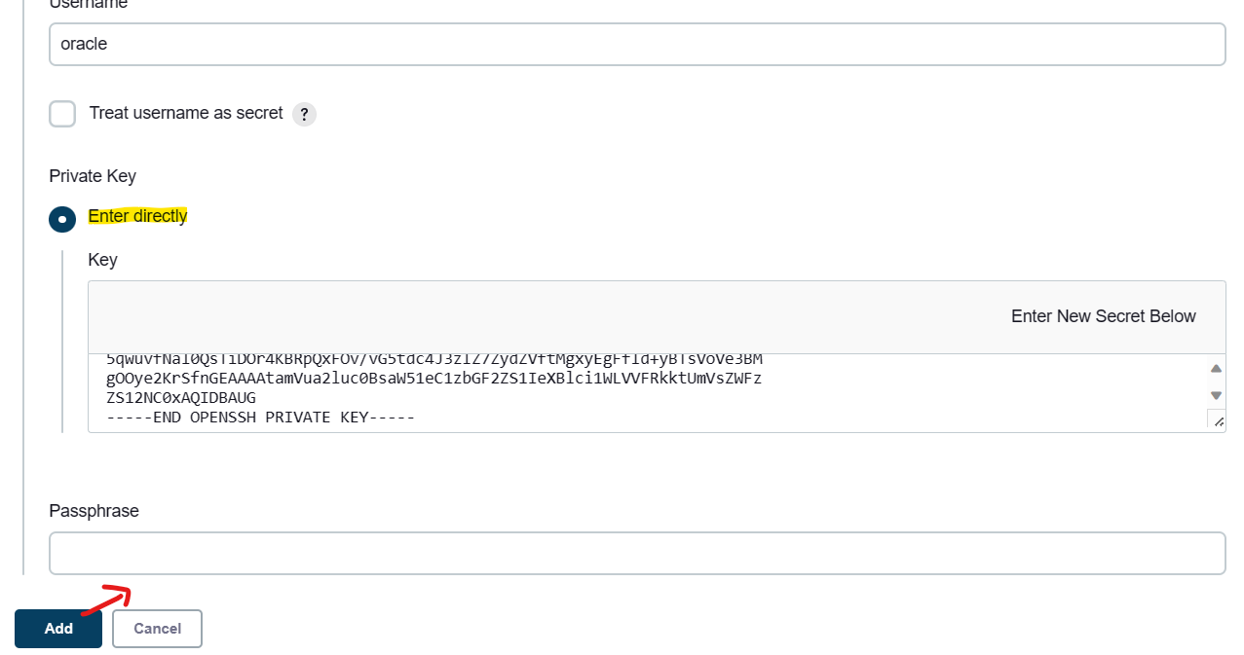

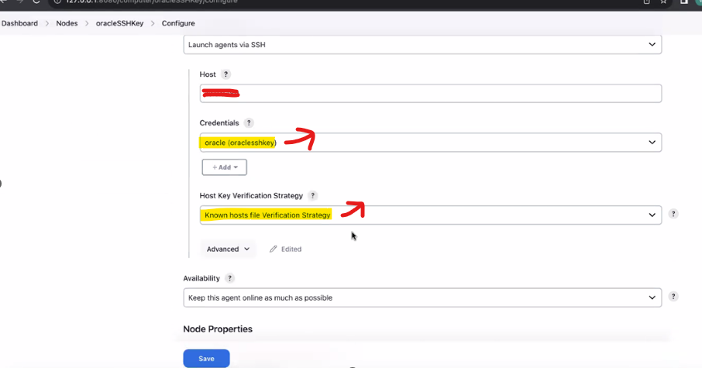

**STEP 10: 🡪 Configure the slave node by clicking Launch Agent via SSH**

* Go to Dashboard -> **Nodes** -> Agent_name.
* Click the Agent_name and click **Launch Agent** button.
* Check the log for the successful launch of the Agent.
* Check the Dashboard – node section which should list the newly added agent with status -In **sync** .

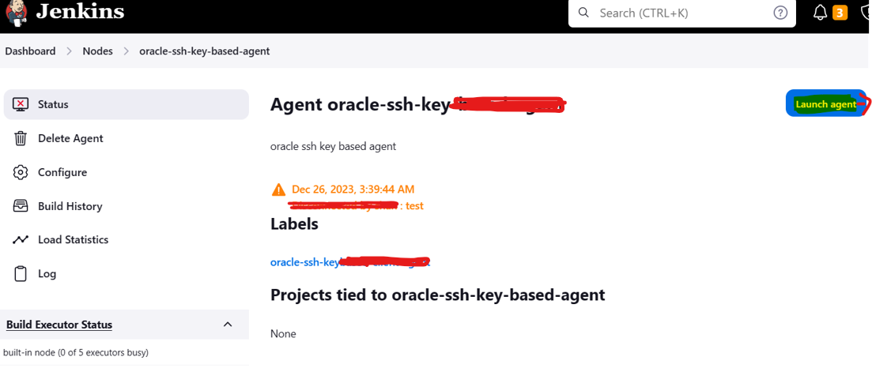

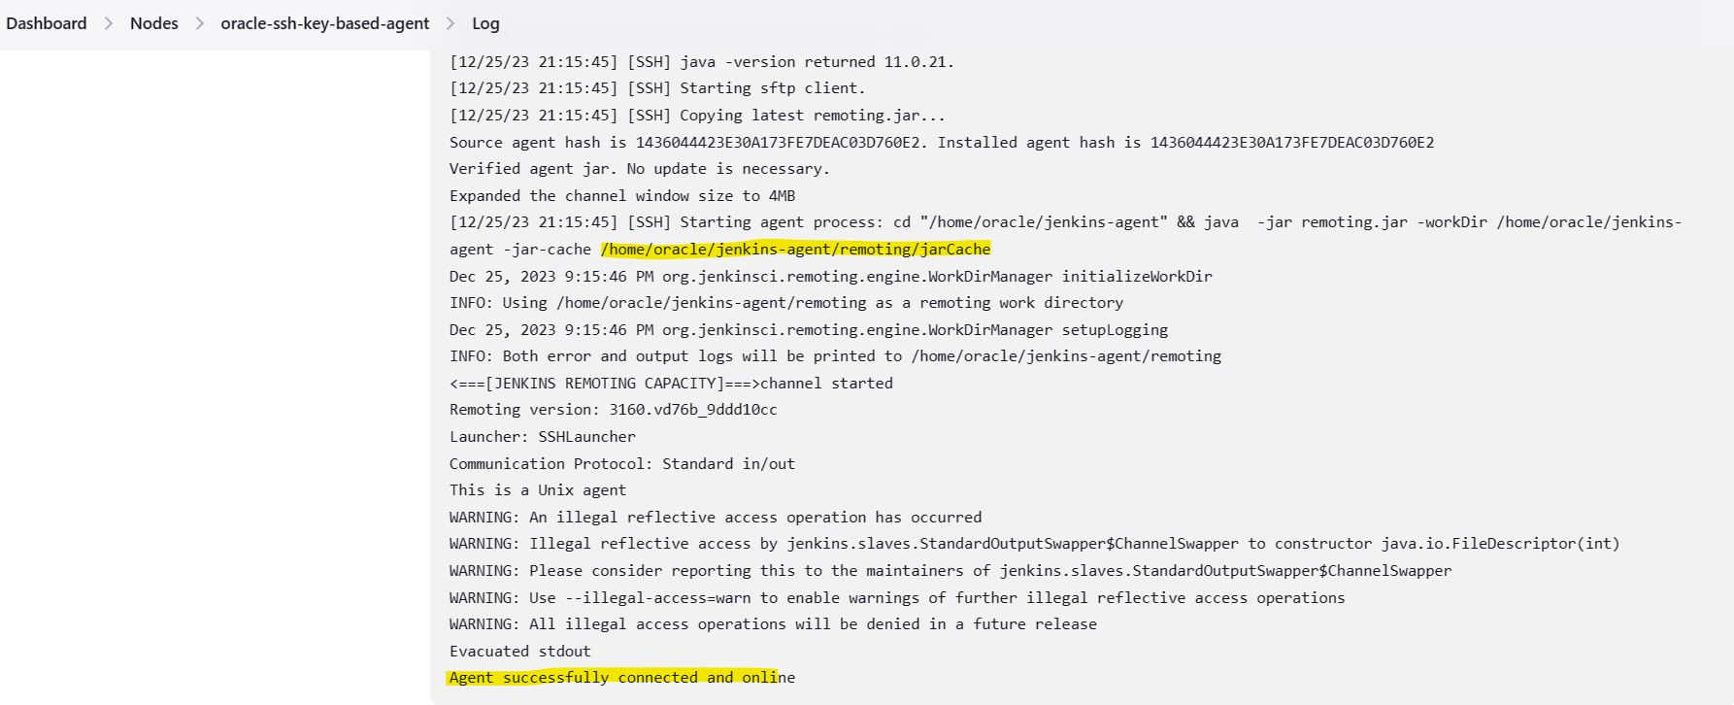

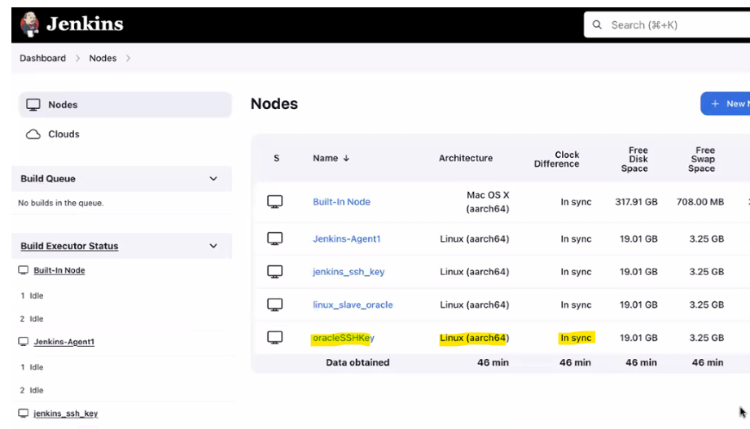

## Written by Vinod Sairam

The Database Administrator who helps to manage Enterprise Databases who develops Devops Engineering ideas to support Database tasks, Infrastructure tasks and to reach the right audience.

**Assisted by Shanmugavelu. M**