**Jenkins job to run SQL code in remote DB server .**

* **SQL code is executed (as shell file) in Oracle DB server (Jenkins Slave server)**

**What is Jenkins:**

* Jenkins is a powerful tool that allows **continuous integration** **(CI)** and **continuous delivery (CD)** of projects, regardless of the platform.
* It is a free source that can handle any kind of build or continuous integration
* We can integrate Jenkins with a number of testing and deployment technologies.

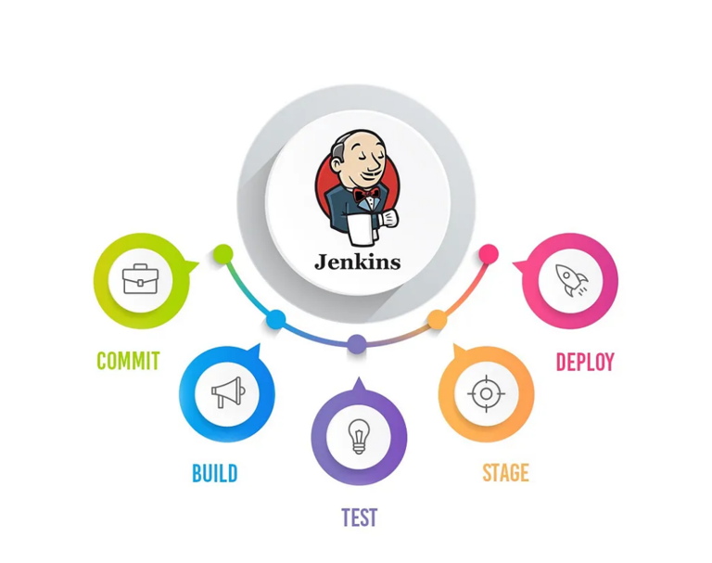

**OS platform :** JenkinsMaster node - Mac OS

**:** Jenkins **Slave** node - Linux

**Database platform :** Oracle DB ( on Slave node)

**:** Version: Oracle 19c

**CI tool used :** Jenkins ( continuous Integration Tool)

**:** URL: <http://localhost:8080/>

**Base Script :** Shell script (from remote DB server)

**:** Script Location:/home/oracle/Jenkins-agent

**Jenkins Job** : Jenkins Job type - ( Freestyle job)

: Goal - Jenkins job to run the SQL code in remote database

**Step 1: Configure Oracle DB server as Jenkins Agent (Slave node):**

* The Oracle DB server act as slave node to run the SQL script from Jenkins .
* The SQL script is treated as a Build job which will be executed from Slave node.
* The jdk files ( java installation files ) has to be copied(or)installed to /home/oracle/jenkins-agent directory .
* The PATH variable and JAVA_HOME variables are to be set in the .bash_profile file as Oracle user.
* The owner of the jdk file should be Oracle user ,If not change the ownership .
* Command : chown -R oracle:oinstall /home/oracle/jenkins-agent/jdk
* The slave node will be in sync when the agent is up and establishes connection by SSH command.

**Set the Environment variable – for Oracle user in slave machine**

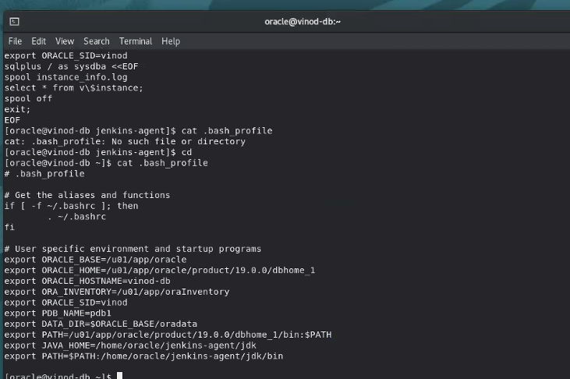

**Test SSH connection as Oracle user: This same SSH should also work from Jenkins**

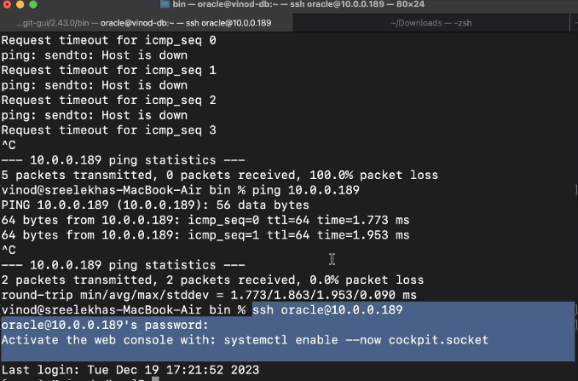

**Configure Slave node ( Oracle server) in Jenkins**

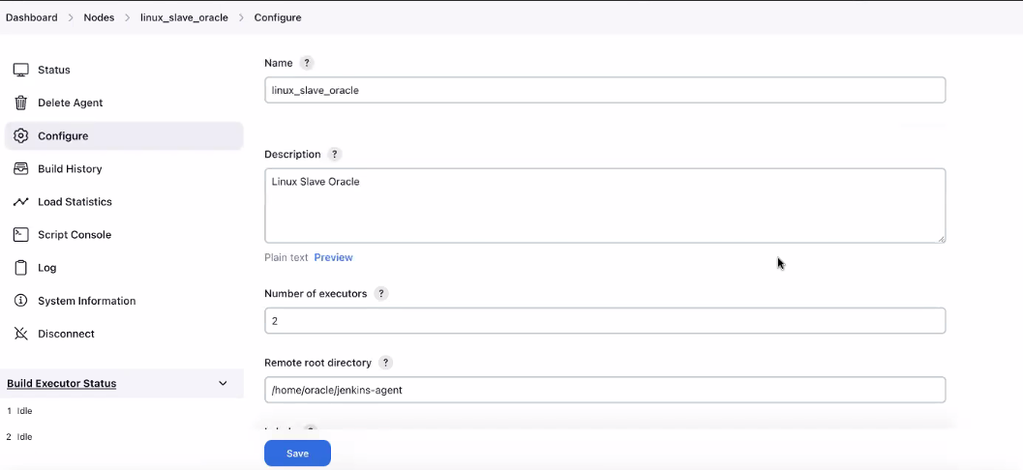

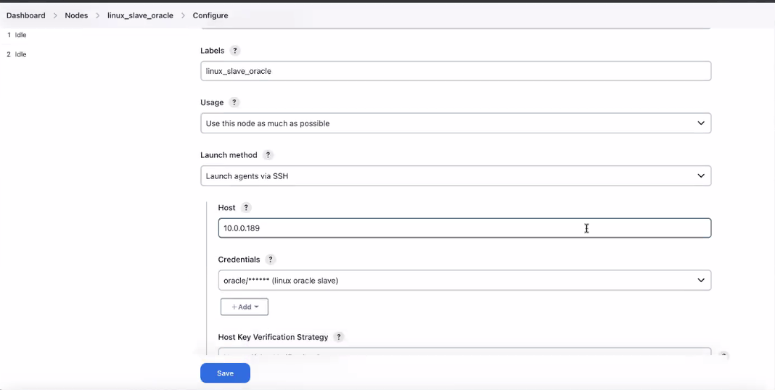

**Slave node (Oracle server) successfully launched in Jenkins agent ( JDK)**

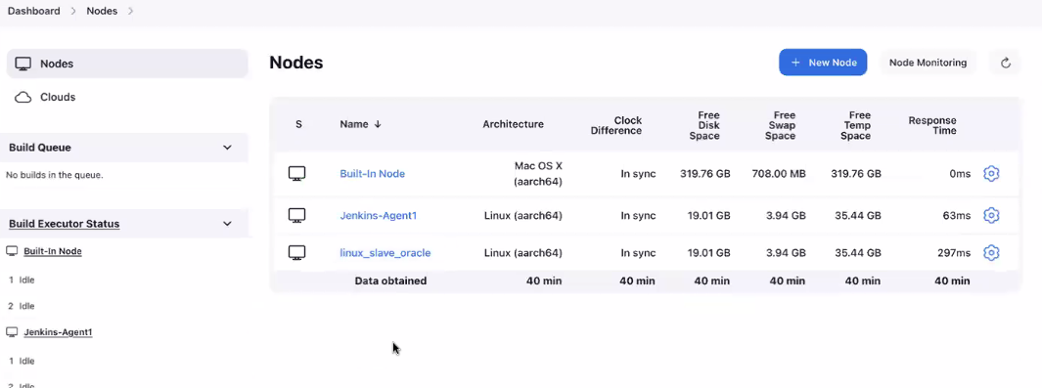

**Step 2: Create/Test a Shell script with SQL code in Oracle DB server (Slave node):**

* Run/Test the shell script independently in the oracle server to execute the SQL query.
* The shell script will be created in agent location /home/oracle/Jenkins-agent
* The shell script contains the SQL query to get executed by the Jenkins job.
* The PATH variable and JAVA_HOME variables are set in the .bash_profile file for Oracle user.
* Test the shell script to execute the SQL code and to provide output.

**Execute/Test the Shell script which will run the SQL code in the database**

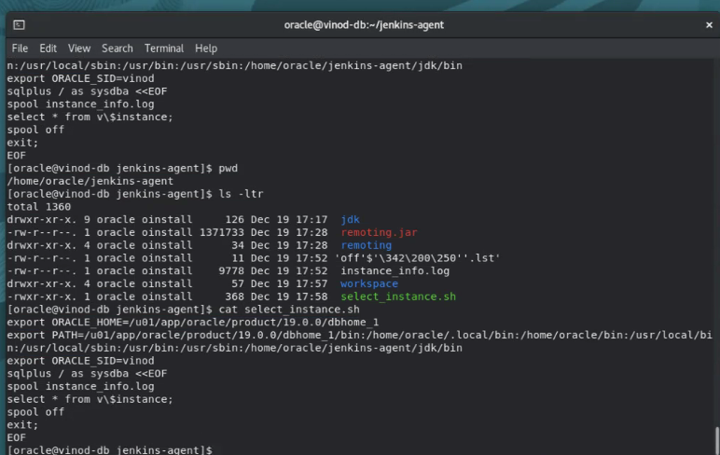

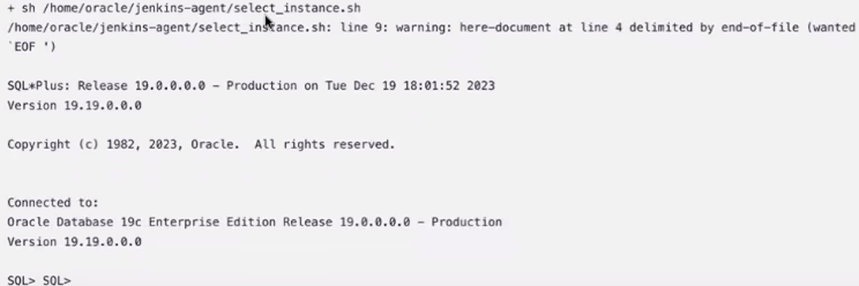

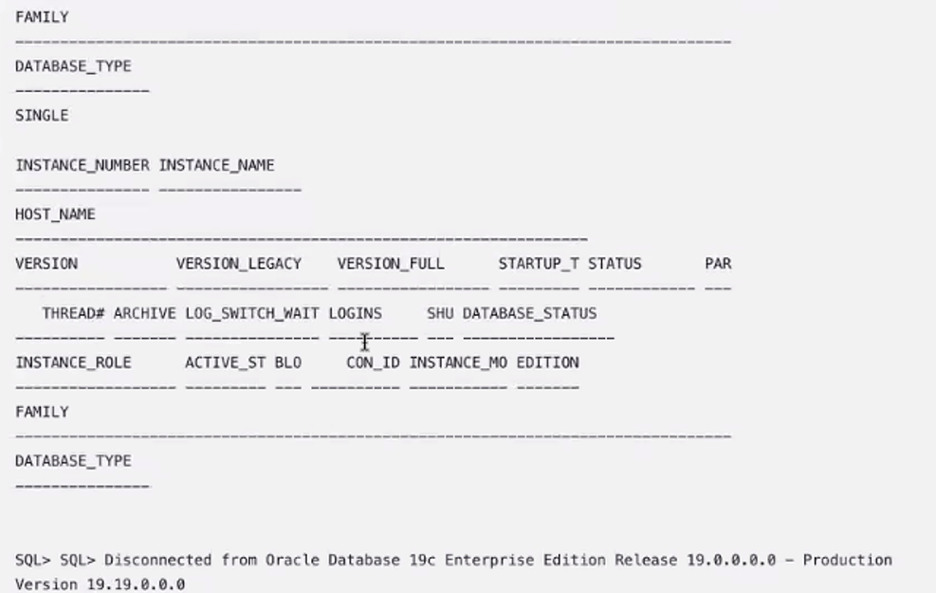

**Step 3: Create a Jenkins job (Free style job) to run SQL as shell file in Slave ( DB server):**

* Create a Jenkins job (Free style job) as per below screenshots
* Add the build step to execute the shell file through Jenkins job.
* Save the Job configuration after providing the details for the shell file to run .
* Click the Build job from the left side pane of the Jenkins tool.

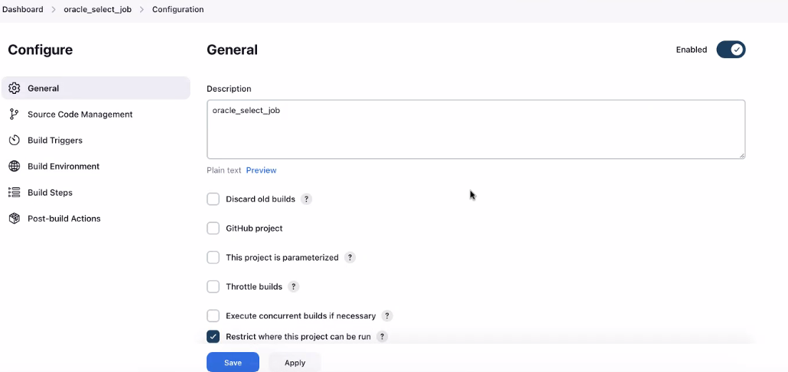

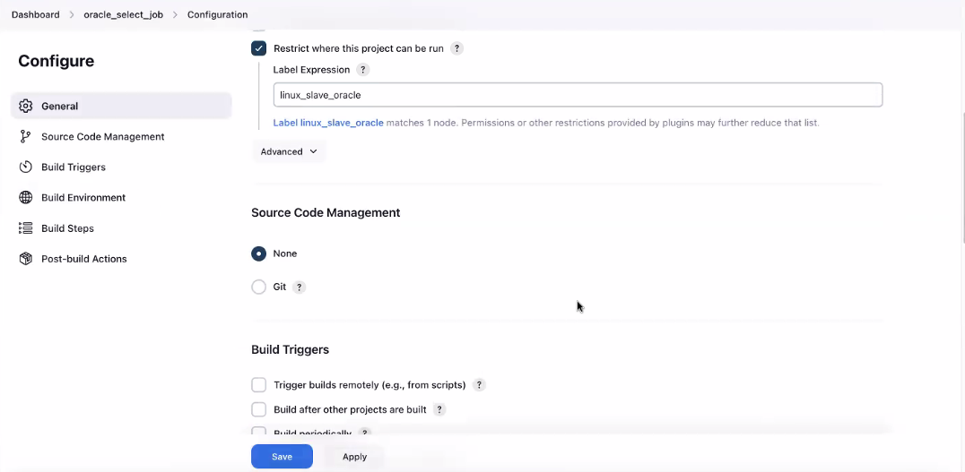

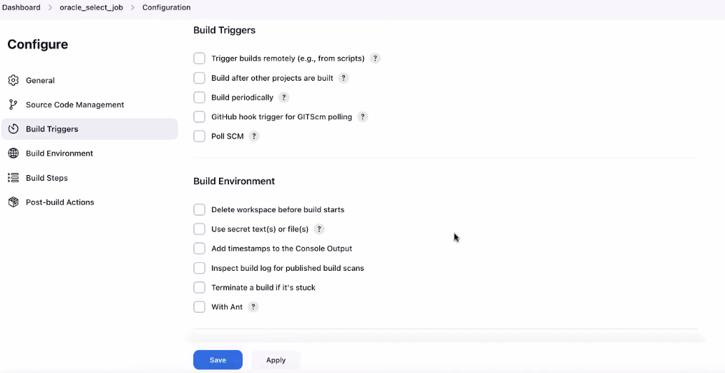

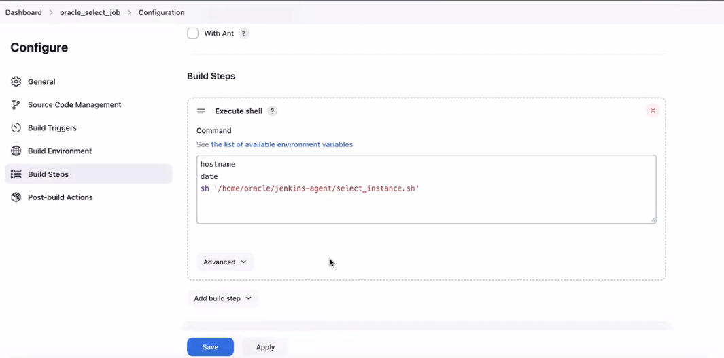

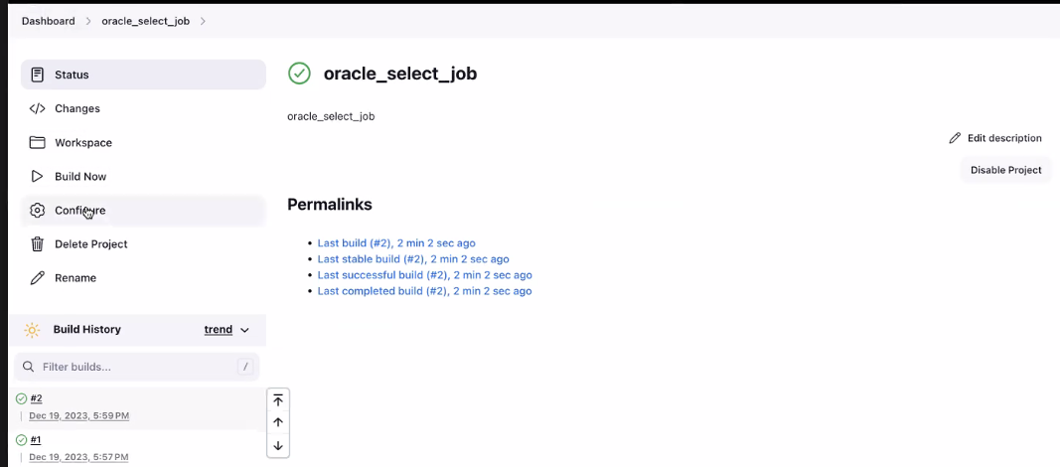

**Step 4: Check the console output of the jenkins job .**

* Check the Job # number turns GREEN for the successful job execution .
* Click the console output of the Jenkins job
* Verify the SQL result in the console output.
* Check the status of the end of console output as SUCCESS.

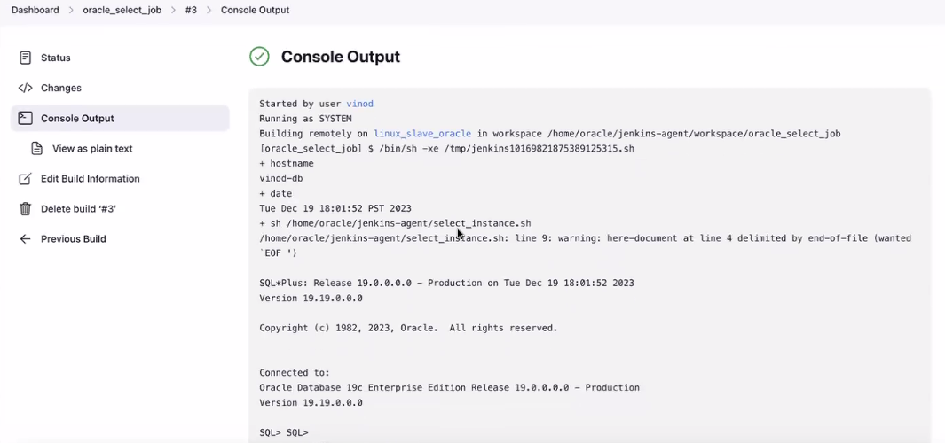

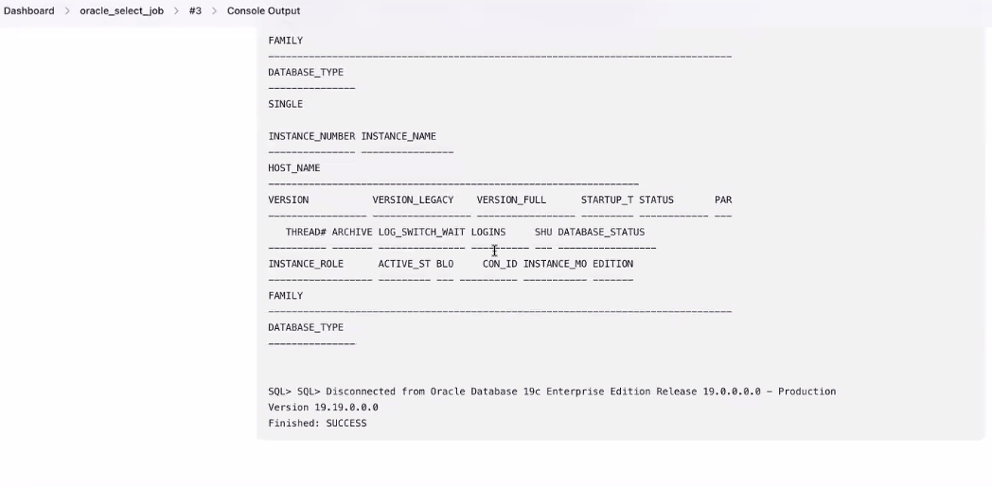

## Written by Vinod Sairam

The Database Administrator who helps to manage Enterprise Databases who develops Devops Engineering ideas to support Database tasks, Infrastructure tasks and to reach the right audience.

**Assisted by Shanmugavelu**