**Jenkins pipeline job to trigger commands/scripts based on time in Oracle DB server**

* This job triggers the commands/scripts based on time (as Oracle user) in Oracle DB server (Jenkins Slave server)
* This job will trigger the job similar to CRONJOB in Unix machine.

**What is Jenkins pipeline?**

* A Pipeline is a collection of occasions interlinked with every difference in a sequence.
* **Jenkins Pipeline** (or simply “Pipeline” with a capital “P”) is a series of events or tasks performed in a specific sequence to transform the code from version control into a stable software product by employing a suite of plugins in Jenkins.
* Thus, enabling the implementation and **integration of** **Continuous Delivery** processes within Jenkins
* Jenkins Pipeline is a mixture of plugins that helps the combination and implementation of non-stop transport pipelines. It has an extensible automation server to create easy and complicated transport pipelines as code through pipeline DSL.

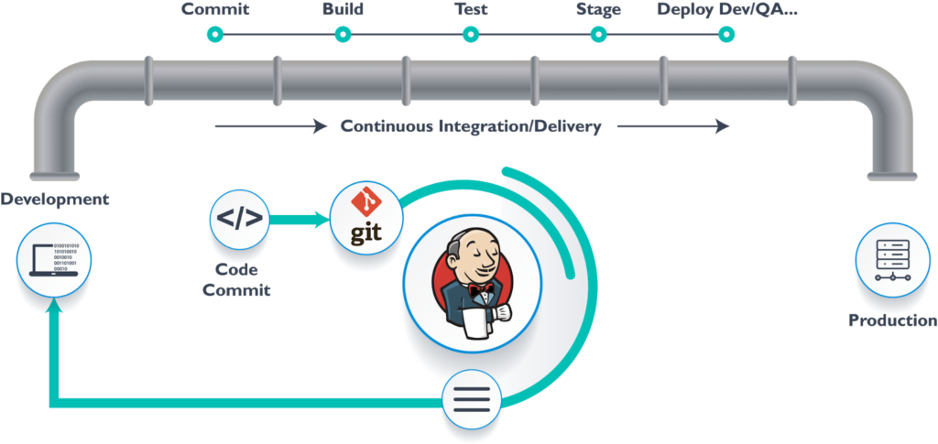

**Why Pipelines?**

* Jenkins is a free, open-source continuous integration server with the capacity to help software development process automation.
* With the aid of use cases, you may design **numerous automation jobs** and run them through a Jenkins pipeline.

**Jenkins pipeline is recommended for the following reasons:**

* Jenkins pipeline is developed using code, allowing numerous people to change and run the pipeline process.
* The pipeline will thus be immediately resumed if your server has to restart for some reason.
* The pipeline process can be stopped, and you can instruct it to not restart until the user provides input.
* Jenkins Pipelines assist with large projects. It's possible to use pipelines in a loop and perform numerous jobs.

**System configuration details:**

|  |  |
| --- | --- |
| Jenkins Master server | **Mac machine** |
| Jenkins Slave server (Agent machine) | **Oracle Linux server** |
| Jenkins pipeline script type | **Declarative pipeline** |
| Jenkins slave OS user to run commands | **Oracle user** |
| Jenkins slave OS user connection type | **SSH key based connection** |
| Jenkins trigger job frequency | **Every one minute (1 minute)** |

**Step 1: Open a new item in Jenkins console to create a job**

* Go to Dashboard in the Jenkins console
* Open a new item in the left side pane of the Jenkins console.

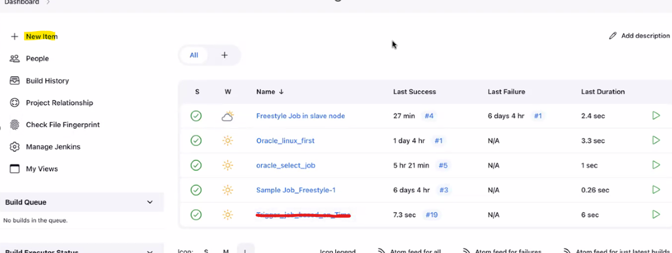

**Step 2: Provide the job name and select pipeline option and click OK**

* Enter the name of the Job to be created
* Select the Pipeline project option and click ok

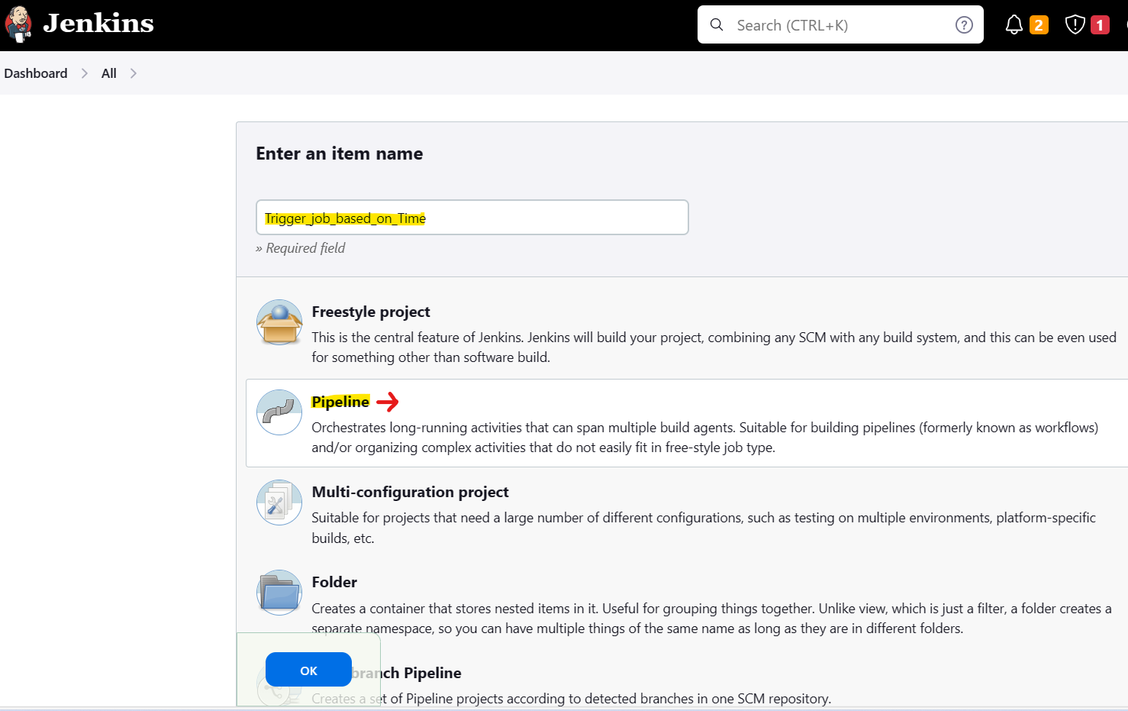

**Step 3: Provide the configuration details for the Trigger job**

* Provide the description of the job, in the General section of the configuration tab.
* Select the Pipeline project option and click ok

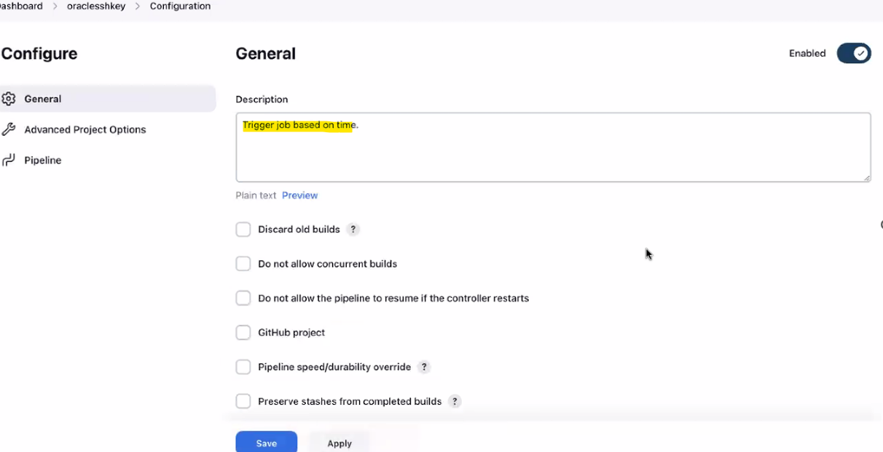

**Step 4: Write the pipeline code under Pipeline section and save**

* Enter the display name under advanced option .
* Write the code in the Pipeline script section
* Then click the save button to save the pipeline job

Note: The Cron command below in this screenshot will run every minute for all 7 days /every day in the week.

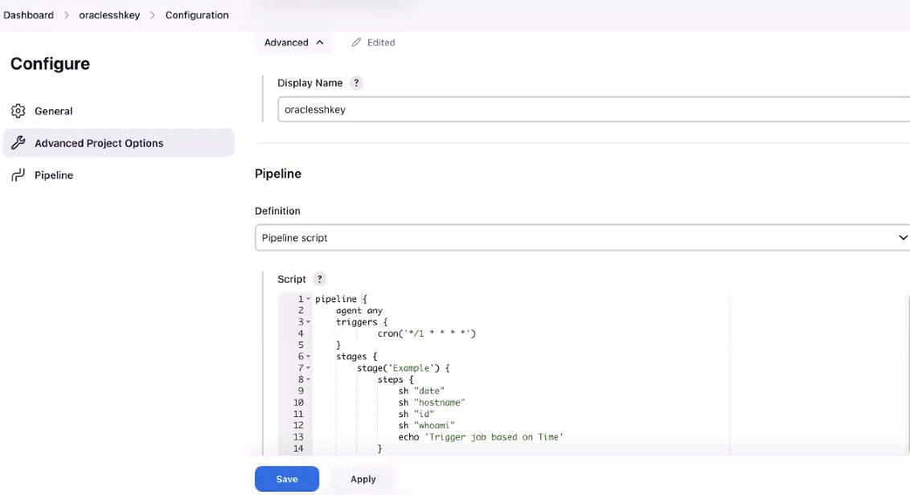

**Step 5: Click the Build Now option to run/test the job for first time**

* Click the Build now option in the Jenkins console
* Then check for the execution status with #number which should turn GREEN for success of the job

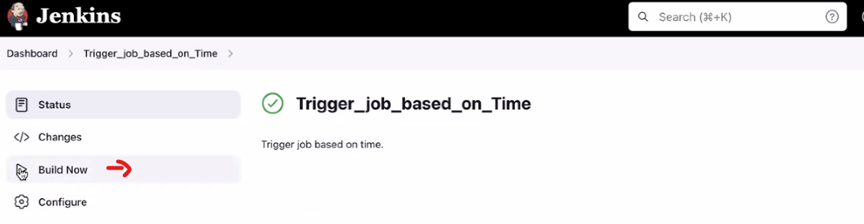

**Step 6: We can observe the job completion is successful as GREEN**

* Click the number# on the left side of the pane in the Jenkins console which should turn GREEN.
* Check for the time the job got executed in the Stage view.
* Also check for the elapse time of the job to complete in the same Stage view.

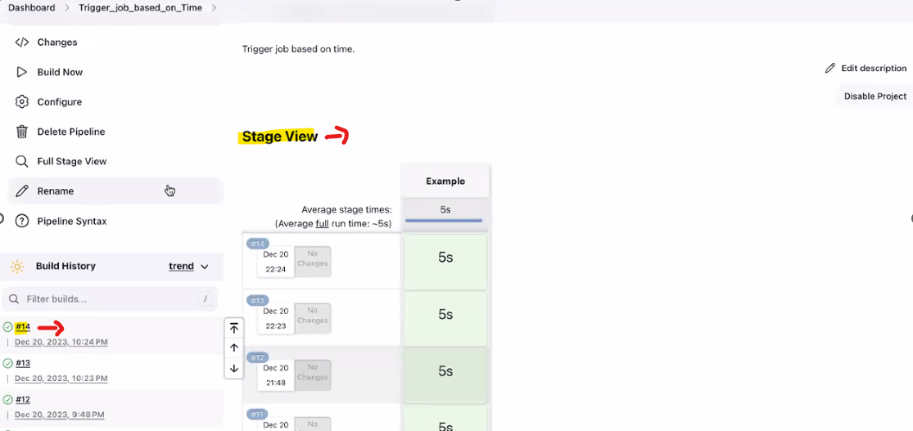

**Step 7: Check the console output of this job .**

* Click the console output of the corresponding job
* Check for output of each command which got executed.
* Also check for the SUCCESS key word at the end of the console output

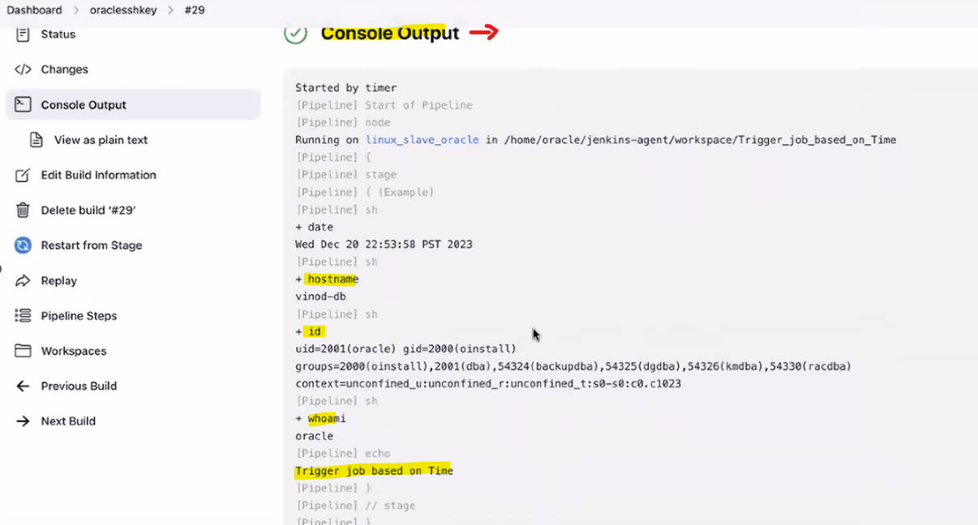

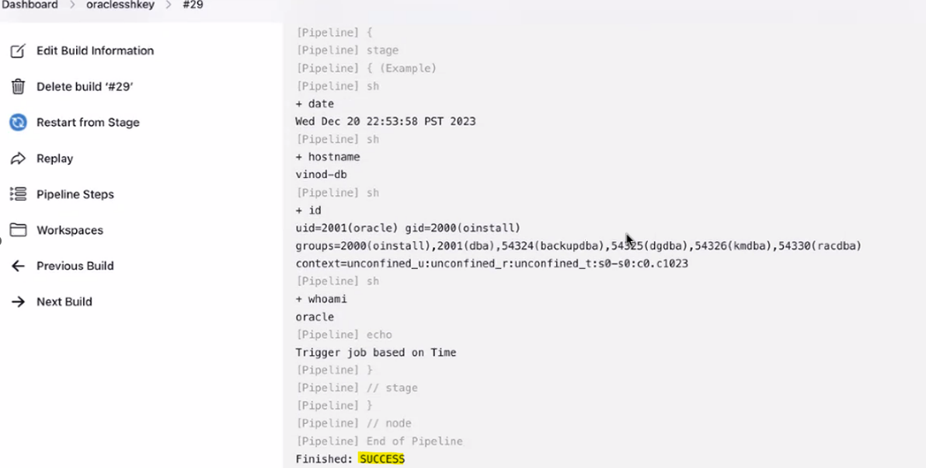

**Step 8: Check the build trigger section that get updated automatically for future RUNS**

* We will observe after successful execution of the job, the build periodically section gets updated with Schedule (under section Build Triggers)
* We can see that the same time schedule gets reflected as mentioned in the pipeline script.
* Based on this Build periodically entry (time schedule), the job gets fired/executed for the next run.

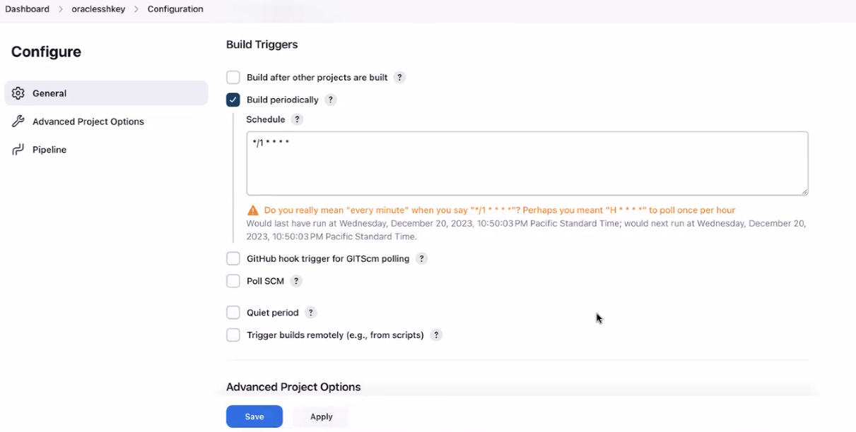

**Step 9: Check that the next RUN of the job triggered automatically**

* Check for the next run of the pipeline job as per the time schedule
* The job should kick of exactly the time mentioned in the cron entry of the script
* We can observe each successful execution and time of execution through stage view.
* The stage view also displays the elapse time of the job.

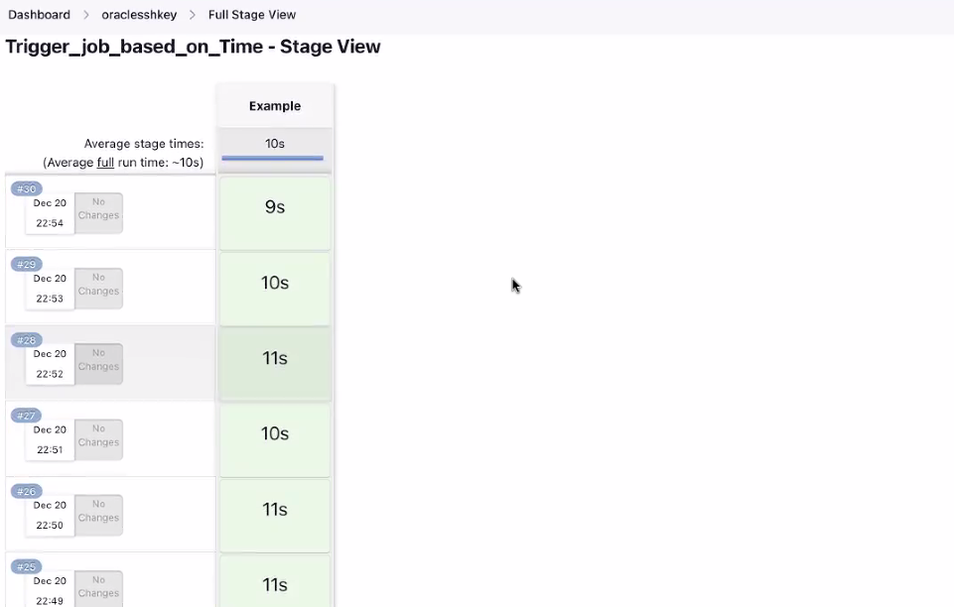

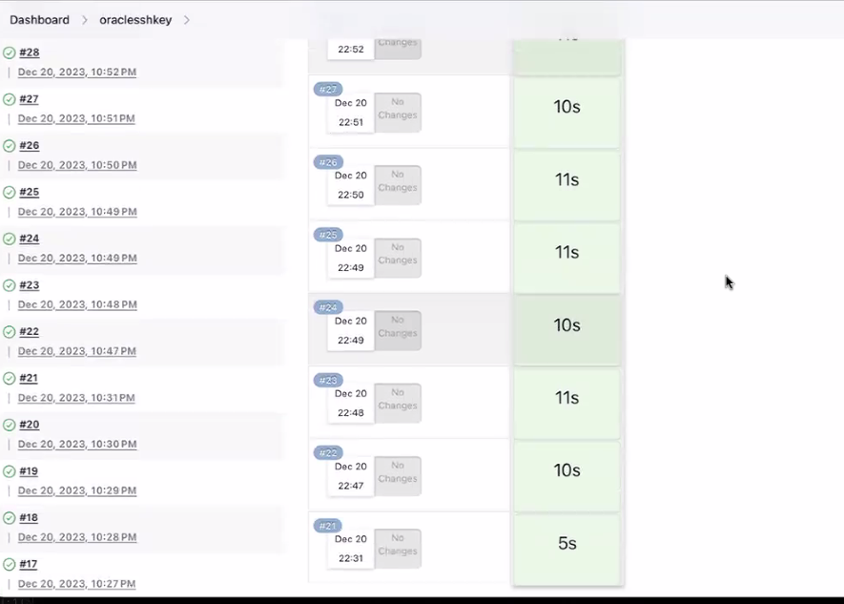

**Step 10: Check the last success/failure time of this job in Dashboard**

* We can check the last success and failure status of the pipeline job in the Dashboard.
* The Dashboard also shows the status of the job (Either success or failure).

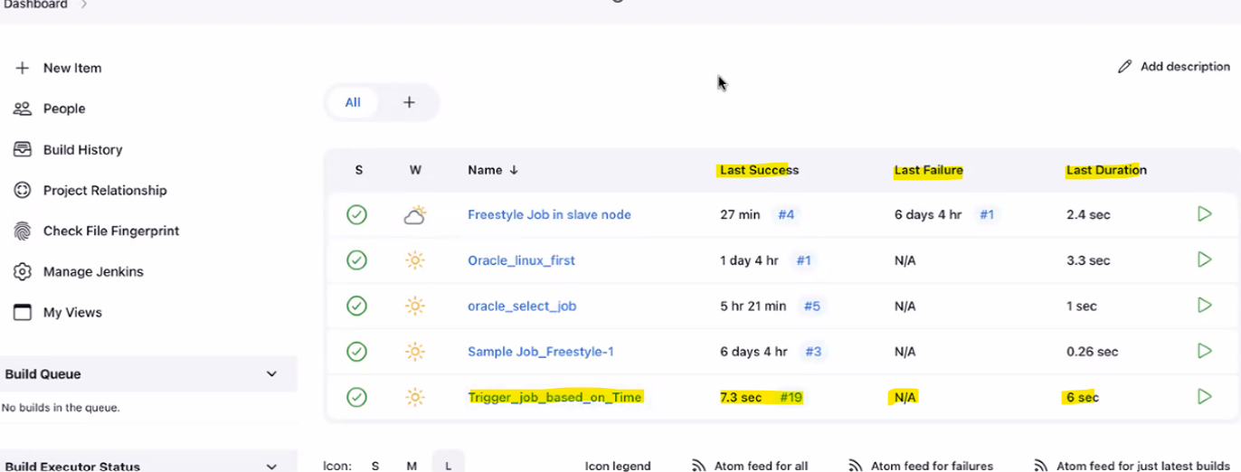

## Written by Vinod Sairam

The Database Administrator who helps to manage Enterprise Databases who develops Devops Engineering ideas to support Database tasks, Infrastructure tasks and to reach the right audience.

**Assisted by Shanmugavelu. M**