**CASSANDRA DATA MODELING TOOLS**

You can create queries and maintain your Cassandra schema with a number of available tools.

**KASHLEV DATA MODELER** : The data modeling process outlined in this paper, which includes defining access patterns, conceptual, logical, and physical data modeling, and schema development, is automated by the Cassandra data modeling tool Kashlev Data Modeler. Additionally, it contains model patterns that you are free to use as a foundation for your ideas.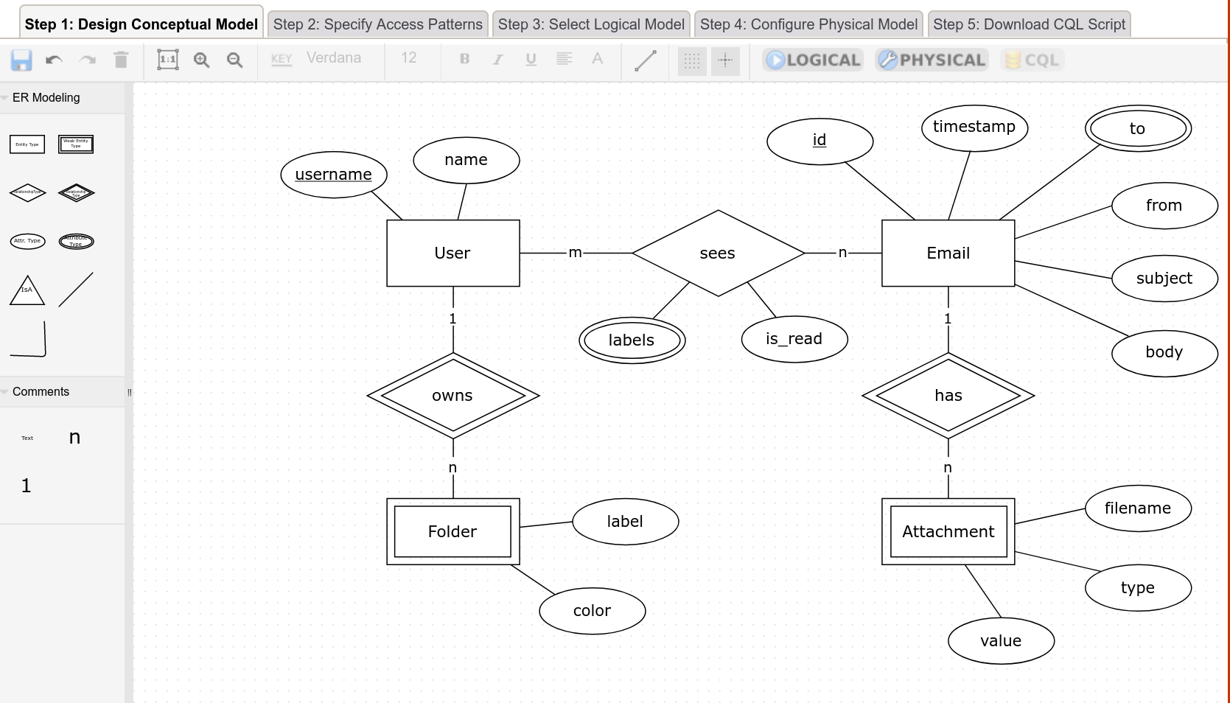**HACKOLADE :**

Cassandra and numerous other NoSQL databases may have their schemas designed using Hackolade, an instrument for data modeling. Hackolade supports data types including collections and UDTs in addition to the special CQL features like partition keys and clustering columns. It can also be used to draw Chebotko diagrams.

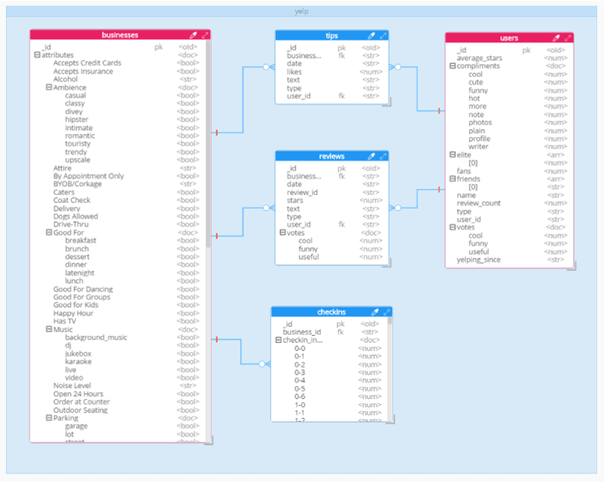

**DATASTAX DEV CENTER :** A tool for managing schema, running queries, and seeing results is called DataStax DevCenter. Although the program is no longer actively supported, many developers still find it useful, and it can be downloaded for free. Syntax highlighting for CQL commands, types, and name literals is available in DevCenter. As you type CQL commands, DevCenter offers command completion and interprets them, underlining any mistakes you make. The program offers windows for managing several connections to different clusters and CQL scripts. CQL commands are executed against active clusters using these connections, and the output is viewed. Additionally, the tool offers a query trace function that helps you see how well your searches are performing.

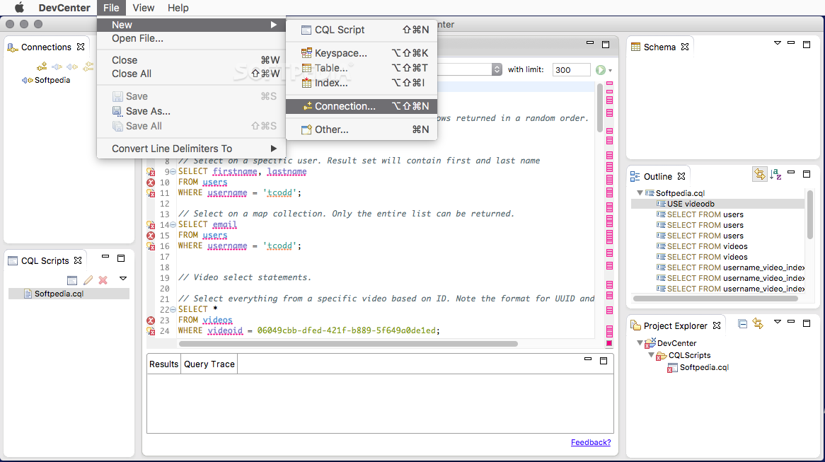

**IDE PLUGINS :** Many Integrated Development Environments (IDEs), including Apache NetBeans and IntelliJ IDEA, have CQL plugins available. Typically, these plugins offer functions like query execution and schema maintenance.

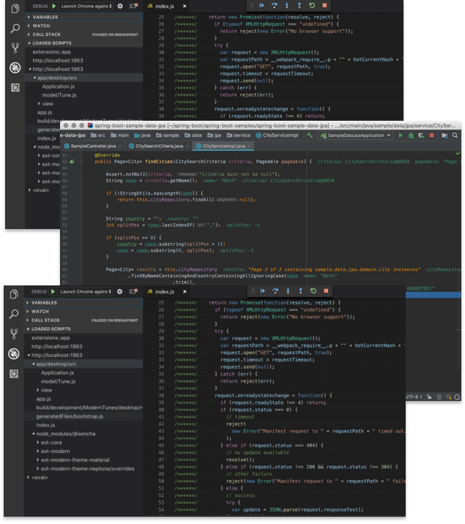

**NOSQL features in APACHE CASSANDRA**

MS Windows, macOS and Linux OS are supported

Support for Apache Cassandra database versions from 2.1 to 4.0, DataStax Enterprise (DSE) versions from 4.0 to 6.8 and DataStax Astra, Amazon Keyspaces for Apache Cassandra, ScyllaDB from 2.0 to 4.4 and Scylla Cloud

Simple management of Cassandra keyspaces, tables, indices, users, user-defined types, triggers, user defined functions, aggregate functions and materialized views

Powerful CQL Editor with multiple queries, syntax highlighting, autocompletion and code snippets

SSH tunneling for Cassandra connections

Database Explorer for easy management of all Cassandra objects

CQL Dump to make a keyspace backup by generating a text file that contains CQL statements

Export data to CSV, XML, JSON and MS Excel file formats

Import data from CSV, JSON and MS Excel file formats

Copy Keyspaces tool to copy keyspaces from one host to another

Import tables from MySQL and SQL Server databases