## **Creating Docker Container using Dockerfile :**

## **Use Case of Docker:**

* Consider a team working on a Java application. Various groups are involved in the Software Development lifecycle: designing, development, testing, production, deployment, etc.

**Step 1:** The developer will create an environment that includes a Tomcat server.

**Step 2:** The tester must test the application after it has been developed. The tester will now create a new Tomcat environment to test the application from scratch.

**Step 3**: The application will be deployed to the production server when the testing is completed. Again, Tomcat must be installed in the production environment to host the Java application.

* The same Tomcat environment setup is done three times. While various teams are engaged in launching the application
* To overcome this problem, we use Docker.
* In Docker, if we can create an image that contains information about required packages, say Tomcat server, to run the Java application, we can share that image to testing and production environment.
* Then, they can run that image which creates a container where the Java application gets hosted in an isolated environment.

[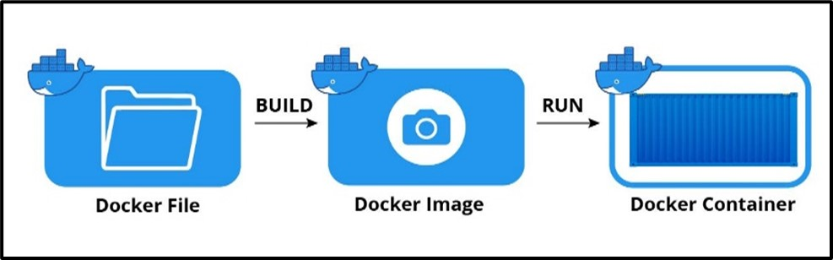](https://content.cloudthat.com/resources/wp-content/uploads/2022/11/docker1.jpg)

**Are containers stateless or stateful?**

* By design, containers are lightweight, ephemeral and stateless.
* But organizations have many options when it comes to using containers for stateful applications.
* Orchestrators such as Kubernetes spin up, stop, destroy and re-create containers in response to changing workload requirements.

**Bringing Statefulness to Containers**

* How can a container be stateful, if it doesn't have persistent storage?
* There are now several well-established vendors that do provide persistent storage for containers, including databases for storing container state information.
* Companies such as [Docker](https://www.contino.io/insights/whos-using-docker), [Kubernetes](https://www.contino.io/insights/whos-using-kubernetes), Flocker, and Mesosphere provide ways of managing both stateless and stateful containers using persistently stored data.
* Most of the key vendors in the container industry appear to see statefulness as a major part of the container landscape, and one that is here to stay, rather than being a vestige of pre-container development style.
* For most developers, the question is not whether to use stateful containers, but when they should be used.

**When should you use stateful containers**

* When should you use stateful containers, and when are stateless containers better?
* Not surprisingly, the answer depends to a large extent on the kind of software that you are deploying, and what it needs to do.
* Does it need to save information about its state, or could it achieve the same results if it were stateless?
* For applications which were designed (or have been refactored) for containers, you can usually ask this question at the microservice level.
* It may turn out that only a handful of containers actually need to store state data, allowing the rest to be run statelessly.

## **Types of Containers in Docker**

There are two types of containers in Docker:

**Stateless Containers:**

* These types of containers do not persist data, i.e., their data is deleted as soon as they are stopped.
* These containers are typically used to run stateless applications such as web servers, reverse proxies, and load balancers.

**Stateful Containers:**

* These types of containers persist data and are typically used to run stateful applications such as databases, message queues, and file servers.
* The data stored inside the container is persistent even if the container is stopped or recreated.

**Additionally, we have -**

**Ephemeral Containers:**

* These types of containers are used for short-lived tasks, such as running one-off commands, performing CI/CD pipeline tasks, etc. They are typically used for testing and debugging purposes.
* They are created and destroyed very quickly and are not meant to be long-lived.
* It’s worth noting that you can use both stateless and stateful containers together to create a complete application.
* For example, you might use a stateless container to run a web server and a stateful container to run a database, and use the network to connect them.

## **Creating Container from Dockerfile**

## **From Docker file 🡪 to Image🡪 to Container**

* It all starts with a **script, set of instructions** that define how to build a specific Docker image.
* This script is called a [Dockerfile](https://phoenixnap.com/kb/create-docker-images-with-dockerfile" \t "_blank).
* The file automatically executes the outlined commands and creates a **Docker image**.
* The command for creating an image from a Dockerfile is **docker build.**
* The image is then used as a template (or base), which a developer can copy and use it to run an application.
* The application needs an isolated environment in which to run – a **container**.
* This environment is not just a virtual “space”. It entirely relies on the image that created it.
* The source code, files, dependencies, and binary libraries, which are all found in the Docker image, are the ones that make up a container.
* To create a container layer from an image, use the command docker create.
* Finally, after you have launched a container from an existing image, you start its service and run the application.

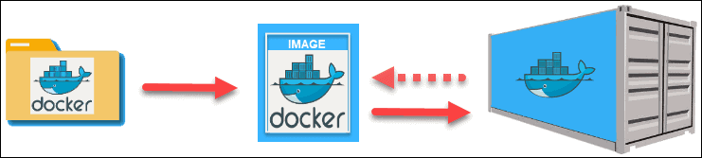

Example :

Creating an App image/container from Docker file

**Step 1: Install the Docker software**

* The first step is to get Docker set up on your machine.
* For the purposes of this tutorial, we’ll be using Docker Desktop on Windows.

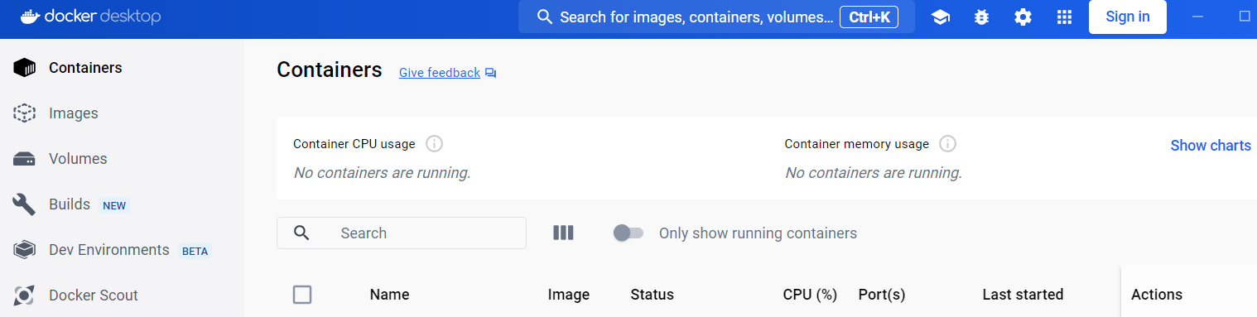

**Step 2: Create the Docker file - with file name as dockerfile**

* Creating a Dockerfile is as simple as creating a text file in your text editor with all the commands you would call in the command line to assemble an image.
* You can name this file whatever you want, but we’ll be using the name “dockerfile” for simplicity..
* Create a Dockerfile in the **‘/app’** directory of your project folder.
* In dockerfile ,we set the working directory to ‘/app’ inside the container.
* Then, we copy the application files from the host machine to the container’s ‘/app’ directory.
* Next, we use the ‘RUN’ instruction to update the package manager and install Python 3 and Flask inside the container. This ensures that the necessary dependencies are installed.
* Finally, we use the ‘CMD’ instruction to specify the command that should be executed when the container starts.
* In this case, it runs the ‘app.py’ Python script using the Python 3 interpreter.
* This Dockerfile can be used to build a Docker image, which is a template for creating containers.
* When the image is built and a container is created from it, the container will have the specified dependencies and will run the specified command when started.

//Docker file content //

# Creating a Dockerfile for Python 3

# Use an existing base image from Docker Hub

FROM ubuntu:latest

# Set the working directory inside the container

WORKDIR /app

# Copy the application files from the host to the container

COPY . .

# Install any required dependencies

RUN apt-get update && apt-get install -y python3 python3-pip

# Install Flask using pip

RUN pip3 install Flask

# Expose a port on the container

EXPOSE 5000

# Specify the command to run when the container starts

CMD ["python3", "app.py","–host", "0.0.0.0"]

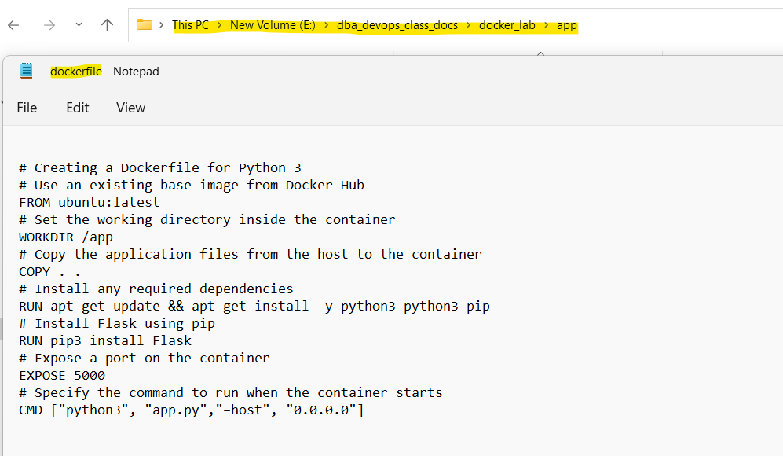

**Step 3: Create the app file app.py – with flask app code**

* In order for this tutorial to work, we’ll also create a simple Flask app in an ‘app.py’ file within the same directory:
* app.py’ file has the flask sample application code

// App file content //

###### from flask import Flask

###### app = Flask(\_\_name\_\_)

###### @app.route(‘/’)

###### def my\_app():

###### return ‘This is a Flask App’

###### if \_\_name\_\_ == ‘\_\_main\_\_’:

###### app.run(host=’0.0.0.0′, port=5000) In this example, we start with an Ubuntu base image pulled from Docker Hub.

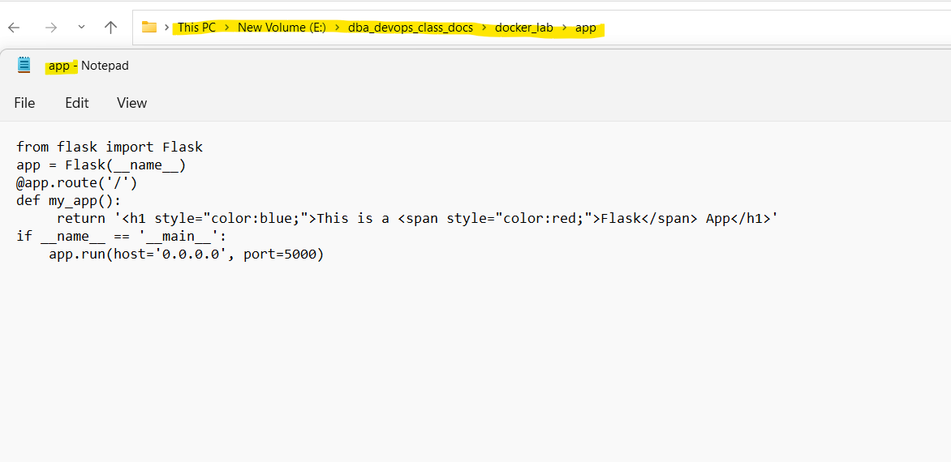

**Step 4: Build the docker image**

* With Dockerfile in hand, you can build the Docker image using the ‘docker build’ command while providing a name for the image with the ‘t’ flag (e.g., ‘myapp:latest’).

In the terminal type:

|  |
| --- |
| **docker build -t myapp:latest .** |

(Don’t forget the ‘.’ at the end)

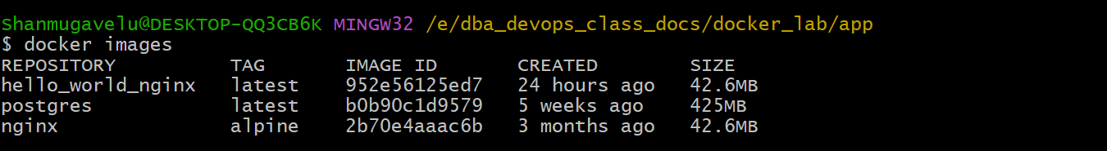

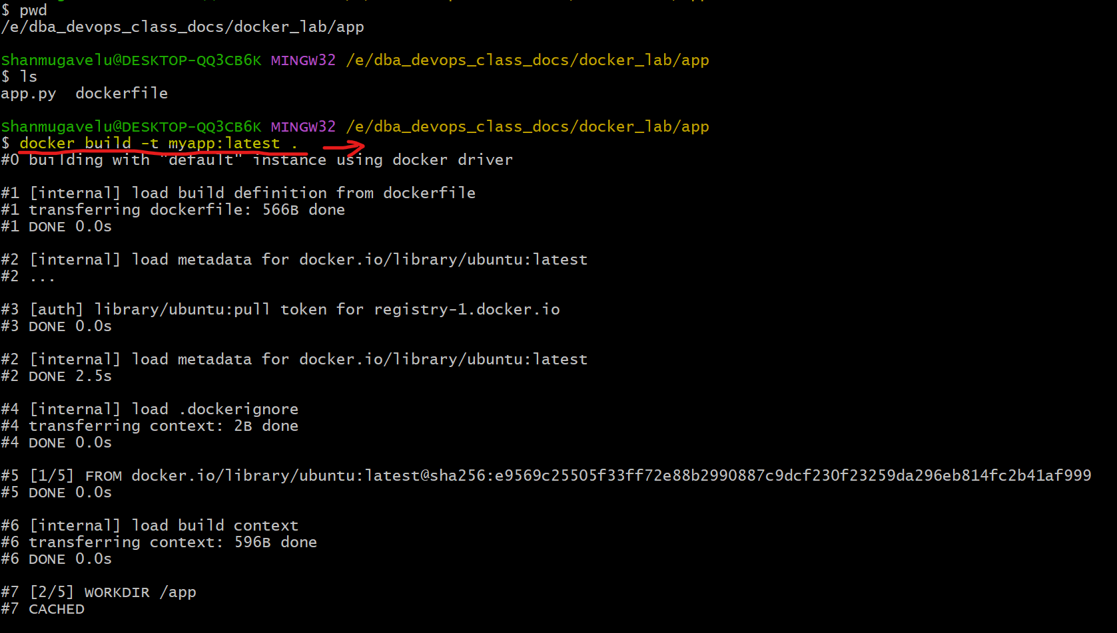

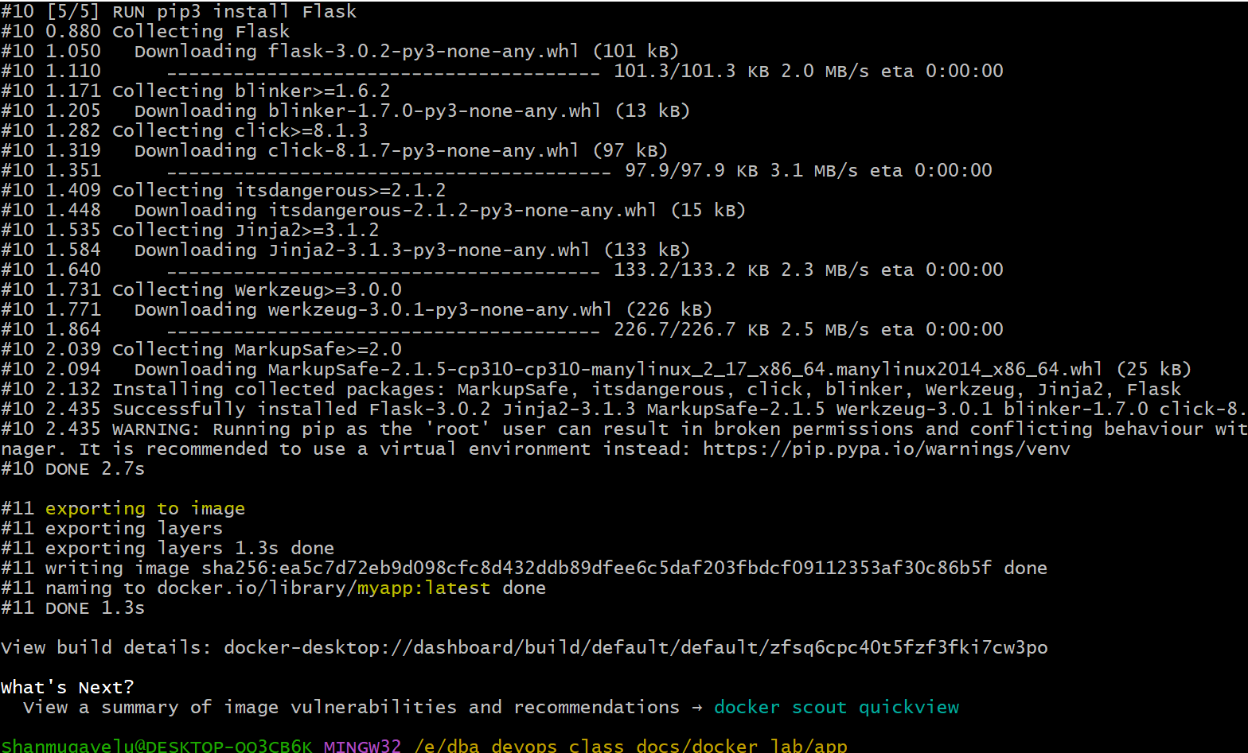

**Step 5: Verify the docker image which is built.**

* You can verify that an image has been created by clicking the Images tab in Docker Desktop (or) from the command line
* Each image can be identified by a name, a tag, and an image ID.

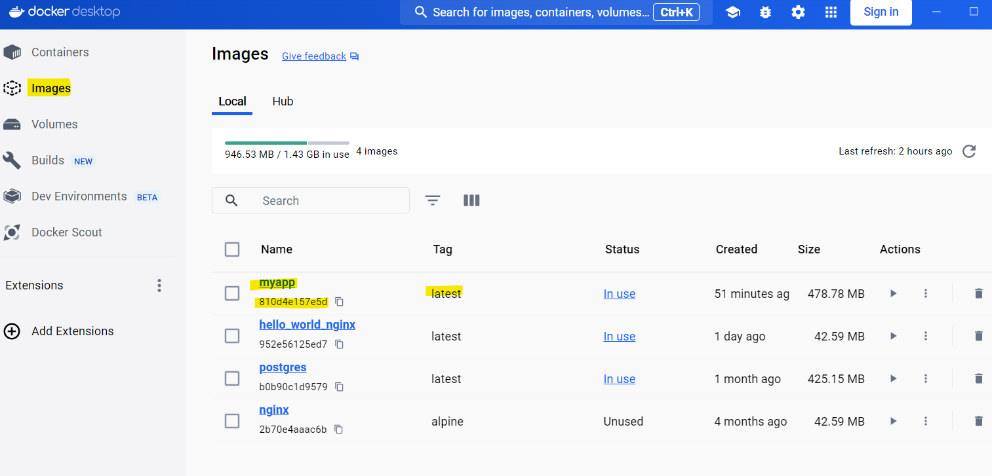

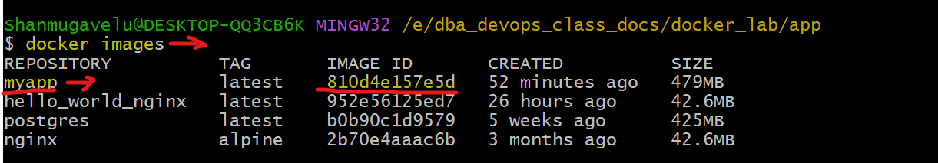

**Step 6: Create/run the container from Docker image :**

* It’s time to create and run a container off of that image.

Type the following command into the terminal

|  |
| --- |
| **docker run -p 5000:5000 --name flask\_app\_cont -d myapp:latest**   * This command will create and run the container flask\_app\_cont * The '–name' tag tells Docker to create and run a container named   'flask\_app\_cont' based off of the image 'myapp:latest'   * You now have an Ubuntu environment running the 'app.py'   file specified within the Dockerfile and Python 3. |
|  |

**Step 7: View the running container:**

* You can view your newly created active container in Docker Desktop
* You can also view from command line

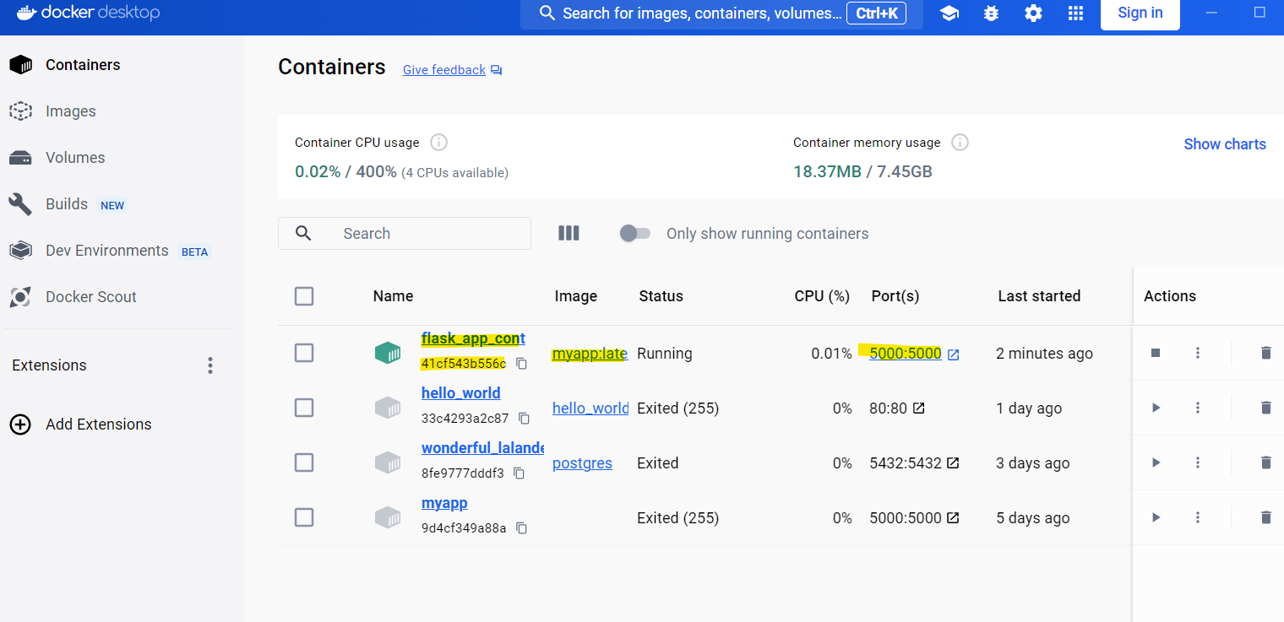

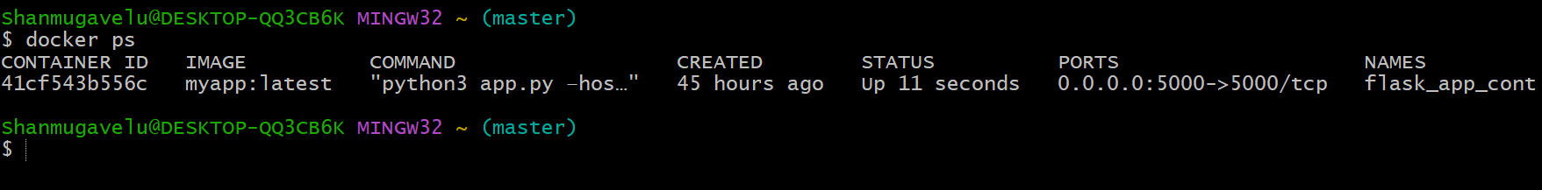

**Step 8: Access/Check the app from Browser:**

* If you navigate to [http://localhost:5000](http://localhost:5000/) in the browser
* It will allow you to see your app printing the text “This is a Flask App.”

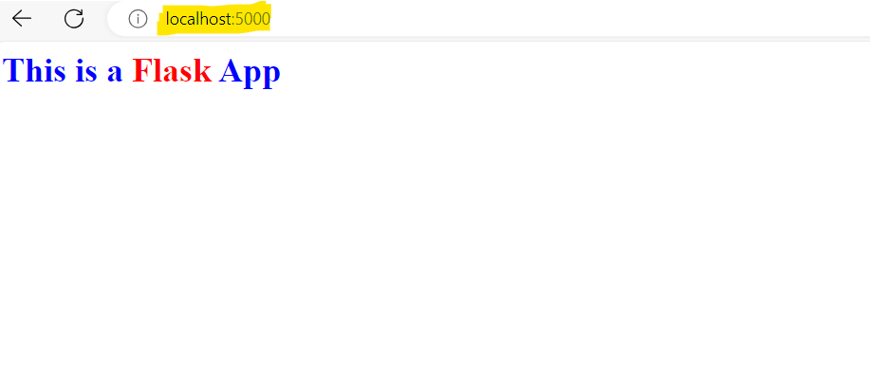

## **Written by Vinod Sairam**

The Database Administrator who helps to manage Enterprise Databases who develops Devops Engineering ideas to support Database tasks, Infrastructure tasks and to reach the right audience.

**Assisted by: Shanmugavelu (Database-Devops Engineer)**